0



Final Year Project 2023

**Developing a GP Web app with Enhanced Analytics for Croydon GP Practice.**

MD Monajir Hussain | B1393756

Contents

1) Introduction 7

2) Scope 7

2.1 Patient No-Show 7

3) Proposed Project Artefact/Project Deliverable(s): 7

4) Project Limitations 8

5) Proposed Project Timeline 9

6) Research 9

6.1) User Analysis 9

6.2) Statistics Report 10

6.3) Target Audience 10

6.3.1) Primary 11

6.3.2) Secondary 11

6.4) Methodology 11

6.4.1)Data Collection: 11

6.4.2) Development methodology 12

6.4.3) Technologies Used 12

6.4.4) Sprints 14

6.4.5) Asana Dashboard 14

6.4.6) Ethics Clearance 15

6.5) Analysis 15

6.5.1) User Persona 1 15

6.5.2) User Persona 2 16

6.5.3) User Persona 3 17

6.6) Requirements & Features List 17

6.7)User Experience/User Interface 19

6.8) Competitor Analysis and Adaptations 20

7) Issues and Considerations 21

7.1)Legal Considerations: 21

7.2)Security Considerations: 21

7.3)Social & Ethical Considerations: 22

8) Design 22

8.1) Mood Board 22

8.2) App Design 24

8.2.1) Use Case Diagram 24

8.2.2) BPMN Diagram 24

8.2.3) CRUD Matrix (Create, Read Update and Delete Table) 25

8.2.4) Navigation Maps 26

8.2.5) Wireframes 27

8.2.6) Prototype 32

8.3) Database Design 36

8.3.1) Normalization 36

8.3.2) Entity Relationship Diagram (ERD) 37

8.3.3) Data Dictionary 38

9) Implementation 40

9.1) Database Implementation 40

9.1.1) Database Overview 40

9.1.2) Database Schema Design 40

9.1.3) Tables 41

9.1.4) Test Data Showcase 43

9.2) PowerApps Implementation 45

9.2.1) Integration with Data/Backend 45

9.2.2) Registration 46

9.2.3) Login Page 47

9.2.4) Header and Footer 48

9.2.5) Home Page 49

9.2.6) Bookings Page 50

9.2.7) Analytics Page 52

9.2.8) About Us Page 53

9.2.9) Contact Us Page 54

9.2.10) Feedback Page 55

9.2.11) Profile Page 57

9.3) Power BI 58

9.3.1) Dataset Overview 58

9.3.2) Data Pre-Processing 59

9.3.3) Data Modelling (Star schema) 61

9.3.4) Visualization 62

9.4) Technical Challenges and Issues 65

10) Testing 66

10.1) Introduction 66

10.2) Objectives 66

10.3) Scope 67

10.4) Test Environment 67

10.5) Test Plan 67

10.6) Risks and Mitigations 71

10.7) Conclusion 71

11) Evaluation and Reflection 71

11.1) Overall Project Evaluation: 71

11.2) Overall Product Evaluation: 72

11.3) Project Limitations: 72

11.4) Future Development: 72

11.5) Own Learning Review: 72

12) References 73

**List of Figures**

Figure 1:Project Timeline 9

Figure 2: Use Case Diagram 24

Figure 3 : BPMN Diagram 25

Figure 4: Patient’s Navigation Map 27

Figure 5: Admin’s Navigation Map 27

Figure 6: Wireframe(Home Page) 28

Figure 7: Wireframe(About Us Page) 28

Figure 8: Wireframe(User Booking Page) 29

Figure 9: Wireframe(Admin Booking Page) 29

Figure 10: Wireframe(Analytics Page) 30

Figure 11: Wireframe(Contact Us Page) 30

Figure 12: Wireframe(Profile Page) 31

Figure 13: Wireframe(Signup/login Page) 31

Figure 14: Prototype(Log In Page) 32

Figure 15: Prototype(Sign Up Page) 32

Figure 16: Prototype(Home Page) 33

Figure 17: Prototype(User Booking Page) 33

Figure 18: Prototype(Create Booking Page) 34

Figure 19: Prototype(About Us Page) 34

Figure 20: Prototype(Analytics Page) 35

Figure 21: Prototype(Contact us Page) 35

Figure 22: Prototype(Profile Page) 36

Figure 23: ERD 38

**List of Images**

Image 1: Image Collage using Canvas 13

Image 2: Final Logo 13

Image 3: Draft Logos 13

Image 4 : Asana Dashboard 15

Image 5: Ethics Clearance Evidence 15

Image 6: Mood Board 22

Image 7: House style 23

Image 8: Preliminary Planning Sketches 23

Image 9: SQL Server Longin 40

Image 10: Schema 41

Image 11: Credentials Table Design Image 12: Table Properties(image 11) 41

Image 13: CreateBooking Table Design Image 14: Table Properties(image 13) 42

Image 15: Contact Table Design Image 16: Table Properties(image 15) 42

Image 17: Feedback Table Design Image 18: Table Properties(Image 17) 43

Image 19: Credentials Test Data 44

Image 20: CreateBooking Test Data 44

Image 21: Contact Test Data 44

Image 22: Feedback Test Data 45

Image 23: Data Connection 45

Image 24: Signup Page 46

Image 25: Signup Button Code 47

Image 26 : Login Page 47

Image 27: Login Button Code 47

Image 28: Reset Button Code 48

Image 29: OTP Email 48

Image 30: OTP Validation 48

Image 31: User Navigations Image 32: Admin Navigations 49

Image 33: Home Page 50

Image 34: Admin Bookings Page 50

Image 35: Time Code 51

Image 36: Reminder Button Code 51

Image 37: User Bookings Page 52

Image 38: Analytics Page 53

Image 39: About Us Page 53

Image 40: Contact Us Page 54

Image 41: Contact Form Page 55

Image 42: User Feedback Page 56

Image 43: Admin Feedback Page 56

Image 44: Priority Colour Schema 57

Image 45: Profile Page 57

Image 46: KaggleV2-May-2016.csv 58

Image 47: Split Columns 60

Image 48 : Conditional Column 60

Image 49: Data Modelling 62

Image 50: Power BI Colour Palette 62

Image 51: Power Bi Dashboard 63

Image 52: Data Cards 63

Image 53: Gauge 64

Image 54: Stacked Column Chart 64

Image 55: Donut Chart 64

Image 56: Clustered Column Chart 65

Image 57: Funnel 65

Image 58: Reset Button Issue 66

Image 59: Create Bookings Button Issue 66

**List of Tables**

Table 1: User Persona 1 16

Table 2: User Persona 2 16

Table 3: User Persona 3 17

Table 4: Competitive Analysis 21

Table 5: CRUD Matrix 26

Table 6: CRUD Matrix Index 26

Table 7: Credential Table 38

Table 8: Create Booking Table 39

Table 9: Contact Table 39

Table 10: Feedback Table 39

Table 11: Test Plan 70

Table 12: Risks and Mitigations 71

# 1) Introduction

In an era characterized by rapid advancements in technology and a growing emphasis on digital solutions, the healthcare sector stands at the forefront of innovation. The integration of technology into healthcare services has revolutionized patient care, facilitating streamlined processes, enhanced communication between healthcare providers and patients, and improved overall efficiency within healthcare systems (Stoumpos, Angelos I et al., 2023).

With the aim of harnessing the power of technology to address existing challenges in healthcare service delivery, the proposed project seeks to develop a comprehensive GP Web app tailored for the Croydon GP Practice. This project aims to leverage modern technologies, including Power Apps and Power BI, to create an intuitive and user-friendly app that enhances appointment management, facilitates seamless communication between patients and healthcare providers, and provides valuable analytics insights to optimize service delivery. Additionally, the app will feature a dedicated analytics page, offering data analysis and visualization to raise awareness and provide valuable information for both healthcare providers and patients.

# 2) Scope

The scope of this project is to design and build an Application for booking and mending appointments. The Web application will be responsive and functional with a modern friendly user interface and user experience. It is aspired contribute to the ongoing digital transformation of healthcare services, ultimately improving patient outcomes and enhancing the overall healthcare experience for individuals within the Croydon community. The GP Application will be developed using Power Apps, with the data being sorted in SQL Database and the data analytic dashboard with the use of Power BI. Therefore this app is chosen to be developed for a bigger cause, to deal with thousands of much-needed GP appointments that are wasted because of patient no-show.

## 2.1 Patient No-Show

Patient no-shows present a significant financial burden on the NHS, with millions of pounds wasted each year due to missed appointments. In 2019 alone, more than 15 million appointments were missed, costing £216 million, and the problem persists, with around 6.4% of booked appointments being missed monthly in 2021/22 (NHS, 2019; NHS England, 2023).

Studies indicate that forgetfulness and practice factors are the primary reasons for missed appointments, and transportation issues further exacerbate the problem, with millions affected in the USA alone (Neal et al., 2005; Tšernov, 2022).

Proposed solutions include reminders via text or phone, charging for missed appointments, or implementing more flexible appointment booking systems. Recent discussions about imposing fines for no-shows underscore the urgency of addressing this issue (Malnick, 2022).

Implementing a patient booking system, such as a convenient Web app, could significantly alleviate the problem by allowing patients to easily manage and cancel appointments, as highlighted by previous research indicating that a quarter of patients tried to cancel or found appointments inconvenient (Neal et al., 2005).

# 3) Proposed Project Artefact/Project Deliverable(s):

The primary project deliverable is a fully functional GP Web app that is compatible with both iOS and Android platforms. The app will provide patients with a user-friendly interface to manage their appointments, reschedule or cancel them as needed, and receive automated reminders to reduce instances of missed appointments. The app will also serve as a powerful analytics tool, incorporating Power BI to offer real-time insights through graphical representations such as charts and graphs. This will enable administrators and the CEO to track and assess the length of appointments, patterns in missed appointments, and service usage across the practice.

The app will offer a secure and personalized section where patients can access their individual health records and personal details. This feature is designed to empower patients by granting them convenient access to their medical history, test results, medication records, and other relevant health information. By having a consolidated view of their health data, patients can take a more active role in their healthcare decisions, fostering a sense of transparency and empowerment.

To further engage patients and improve the quality of service, the app will feature a dedicated section for surveys and feedback. Patients will be encouraged to provide input on their healthcare experiences, including their opinions on appointment duration, the quality of service received, and any suggestions for improvement. This feedback mechanism will be a valuable tool for healthcare providers to continually enhance their services and tailor them to the needs and expectations of their patient community.

By integrating these additional features into the GP App, the project aims to create a holistic solution that not only streamlines appointment management and provides robust analytics but also fosters a patient-centred approach. Patients will have the ability to actively participate in their own healthcare journey, access their health records, and offer their feedback, ultimately contributing to an improved healthcare experience at Croydon GP Practice.

In terms of technology, the app will be built using PowerApps, a Microsoft platform that facilitates rapid application development, and Power BI, a business analytics tool (Bishalgoswami et al., 2023). The app will also ensure seamless integration with Electronic Health Record (EHR) systems to access comprehensive patient data. For supporting documents, Lucid Chart and Canvas will be used, however to manage the project, project management tool called Asana will be used.

# 4) Project Limitations

While the proposed project aims to address several challenges in healthcare service delivery through the development of a comprehensive GP App, it is important to acknowledge and address certain limitations that may impact the scope and execution of the project. These limitations include:

**1. Time Constraints:** The project is bound by time constraints, which may impact the depth of research, development, and testing phases. Adhering to project timelines while ensuring quality deliverables poses a significant challenge.

**2. Learning Curve:** As the project involves learning and mastering modern technologies such as Power Apps and Power BI, there may be a learning curve, potentially affecting the speed and efficiency of development tasks.

**3. Resource Constraints:** Limited resources, including non-subscription, workforce, and technical infrastructure, may restrict the extent to which project objectives can be realized. Balancing resource allocation with project requirements poses a challenge (Gupta, 2023).

**4. Technical Challenges**: The integration of complex functionalities, such as real-time analytics and bookings, may present technical challenges during the development phase. Overcoming technical hurdles while maintaining project timelines is crucial.

**7. Scalability and Future-proofing:** Designing the app to accommodate future scalability and evolving user needs requires careful consideration. Anticipating future requirements and ensuring the app's adaptability to technological advancements is crucial for long-term success (Tinderhouse, 2023).

# 5) Proposed Project Timeline

The Chart_1 shows the proposed timeline for the project, and also shows how slightly some tasks were delayed.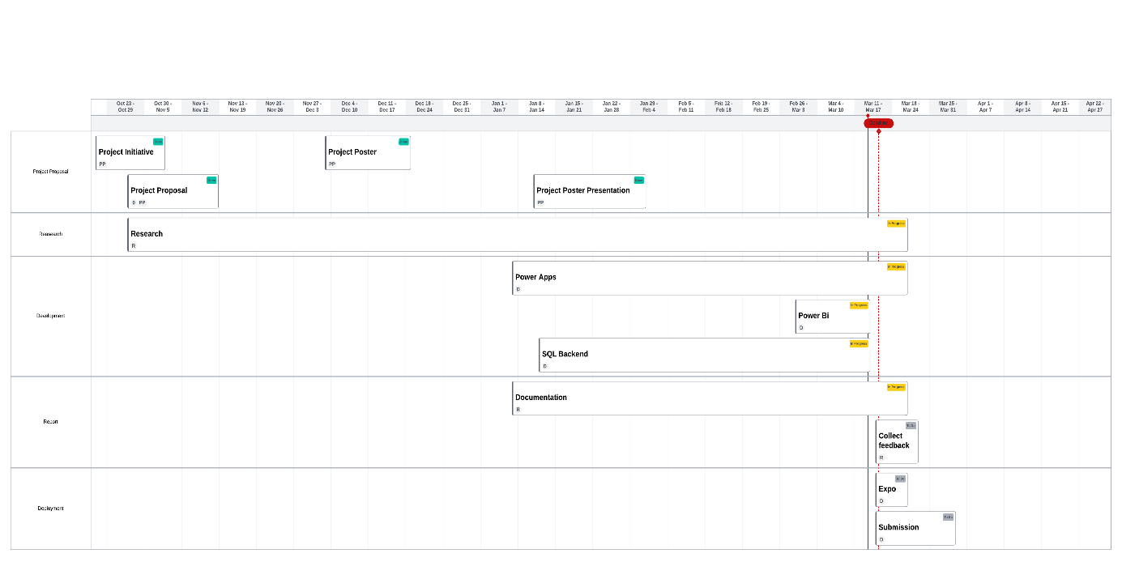

Figure 1:Project Timeline

# 6) Research

## 6.1) User Analysis

Understanding the needs, goals, and challenges of each user group is essential for designing an app that caters to their specific requirements, ultimately enhancing their experience and facilitating efficient healthcare service delivery (Strazhevich, 2023).

**1.** **Patients:**

- Demographics: Patients of all ages and backgrounds residing in the Croydon area.

- Needs and Goals: Seeking convenient access to healthcare services, including booking, rescheduling, and managing appointments. Desire for timely reminders and easy communication with healthcare providers.

- Challenges: Limited time availability, difficulty remembering appointments, communication barriers with healthcare providers or feeling better by the time of the appointment (Parsons, J., Bryce, C., & Atherton, H., 2021).

**2. General Practitioners (GPs):**

- Demographics: Healthcare professionals practicing in Croydon GP practices.

- Needs and Goals: Efficient appointment management, effective communication with patients, and access to patient records. Desire for tools to streamline administrative tasks and enhance patient care.

- Challenges: Managing a high volume of appointments, maintaining accurate patient records, and ensuring timely communication with patients.

**3. Administrators:**

- Demographics: Staff responsible for administrative tasks within GP practices.

- Needs and Goals: Streamlining appointment scheduling, managing patient records, and generating reports on practice performance. Desire for tools to optimize practice operations and improve efficiency.

- Challenges: Balancing administrative duties with patient care, maintaining accurate records, and managing practice resources effectively.

## 6.2) Statistics Report

Patient no-shows represent a significant challenge for healthcare operations, leading to resource wastage and operational instability. Studies have revealed a wide range of no-show rates, from 12% to 80%, across different healthcare settings. Various factors influence these rates, including demographic variables such as gender, age, and socioeconomic status, as well as service-related factors like appointment lead times and waiting times. Research indicates that men, younger individuals, and those from lower socioeconomic backgrounds are more likely to miss appointments. Additionally, studies conducted in rural free clinics in South-Eastern America have identified transportation difficulties, fear of healthcare providers, and adverse weather conditions as contributing factors to no-shows, underscoring the multifaceted nature of this issue (Marbouh, Dounia et al, 2020).

Addressing the challenge of patient no-shows requires targeted interventions aimed at mitigating their impact on healthcare operations. Strategies such as appointment reminders, improved service quality, and reduced waiting times can help reduce no-show rates. Furthermore, interventions should be tailored to demographic groups identified as more prone to missing appointments, including men, younger individuals, and those from lower socioeconomic backgrounds. Systemic barriers contributing to no-shows, such as transportation difficulties and fear of healthcare providers, should also be addressed through community outreach and support programs (Leila, F., Julia L., & Fernando L., 2018). By implementing these proactive measures, healthcare providers can enhance appointment adherence and improve overall service delivery, ultimately ensuring better outcomes for both patients and healthcare facilities.

## 6.3) Target Audience

Identifying the primary and secondary target audiences for the app is crucial for effective marketing and product development. Here is a breakdown of potential target audiences for a GP Web app:

### 6.3.1) Primary

**1. Patients:**

- Individuals seeking medical appointments for themselves or their family members.

- Those looking for convenient and accessible healthcare solutions.

- People with chronic conditions requiring regular medical consultations.

- Tech-savvy individuals comfortable with using Web apps for managing their health.

### 6.3.2) Secondary

**1. Healthcare Providers:**

- General practitioners (GPs) and other medical professionals looking to optimize their appointment scheduling and patient management processes.

- Allied healthcare professionals, such as nurses or pharmacists, involved in patient care coordination.

**2. Caregivers and Family Members:**

- Individuals responsible for managing the healthcare needs of elderly parents or young children.

- Caregivers seeking tools to streamline appointment booking and medication management for their dependents.

**3. Healthcare Administrators:**

- Hospital administrators or clinic managers interested in adopting digital solutions to improve operational efficiency and patient satisfaction.

By understanding the primary and secondary target audiences for the app, it will be significant to tailor marketing strategies, user experience design, and feature development to meet the diverse needs and preferences of GP.

## 6.4) Methodology

### 6.4.1)Data Collection:

In order to better understand user demands, behaviours, and preferences and to improve patient care, data collecting is an essential component of this project. In order to accomplish this, quantitative data will be gathered to offer a thorough understanding of users' needs and experiences; at this time, qualitative data will not be gathered.

- Quantitative Data Collection: Formal questionnaires will be used to collect quantitative data. The purpose of the surveys is to gather predetermined answers and numerical data. Getting quantitative information about user preferences, satisfaction levels, and feature effectiveness for the app is the goal. The smartphone app will be used to administer these electronic questionnaires, making it easy for users to submit feedback (Creswell, J. W., & Creswell, J. D. 2017).

### 6.4.2) Development methodology

The Agile development methodology will serve as the main strategy for this project. Agile places a strong emphasis on adaptability, teamwork, and response to shifting needs. This approach is perfect for creating a GP Web app that focuses on improving patient care since it works effectively for projects where user feedback and changing demands are crucial.

The following guidelines and procedures will define agile development for this project:

1. User Stories: Creation of user stories to define features and functionalities from the user's perspective. These stories will capture the requirements and expectations of various user roles, including patients, GPs, and administrators.
2. Sprints: Work will be organized into time-bound iterations known as sprints. Each sprint will typically last two to four weeks, during which a set of user stories will be developed, tested, and released. This allows for incremental progress and frequent user feedback.
3. Continuous Testing: Continuous testing of features to identify and address issues early in the development process. Testing will include both functional and user acceptance testing to ensure that the app meets user requirements and quality standards.
4. User Feedback Integration: Agile allows for the incorporation of user feedback after each sprint, ensuring that the app remains responsive to evolving user needs and preferences.
5. Adaptability: Agile development allows for changes and adjustments to the project scope as needed, ensuring that the project remains aligned with user expectations.
6. Iterative Improvements: Throughout the project, continuous improvement of the app based on user feedback and evolving healthcare needs is a key principle of Agile development.

(Schwaber, K., & Sutherland, J., 2017).

### 6.4.3) Technologies Used

In the development of the Croydon GP application, several technologies have been utilized to ensure its functionality and user experience meet the desired standards.

[**Power Apps:**](https://make.powerapps.com/)

Power Apps has been employed for the front end of the application, offering a user-friendly interface for seamless navigation. Despite its benefits, Power Apps does have some drawbacks, such as limitations in complex app design and licencing issues.

[**Power BI:**](https://app.powerbi.com/)

Power BI serves as the backbone for data analysis, enabling quick processing of over 65,000 health records from Brazil in seconds. This facilitates the extraction of key performance indicators (KPIs) essential for informed decision-making within the app. The beauty of power BI has big horizon and its also easy to use (Gestisoft, 2023).

**MSQL:**

MSQL was chosen as the backend technology due to its reliability and the developer's extensive three years of experience with the platform. Additionally, the availability of SQL in the university environment eliminated the need for additional costs associated with other backend solutions like SharePoint. While SharePoint could have supported most of the application's functionalities, SQL provided a cost-effective alternative.

**Canvas:**

Canvas was instrumental in designing the app's layouts and custom images, ensuring alignment with the overall theme. Some images/layouts made using Canvas are as follows:

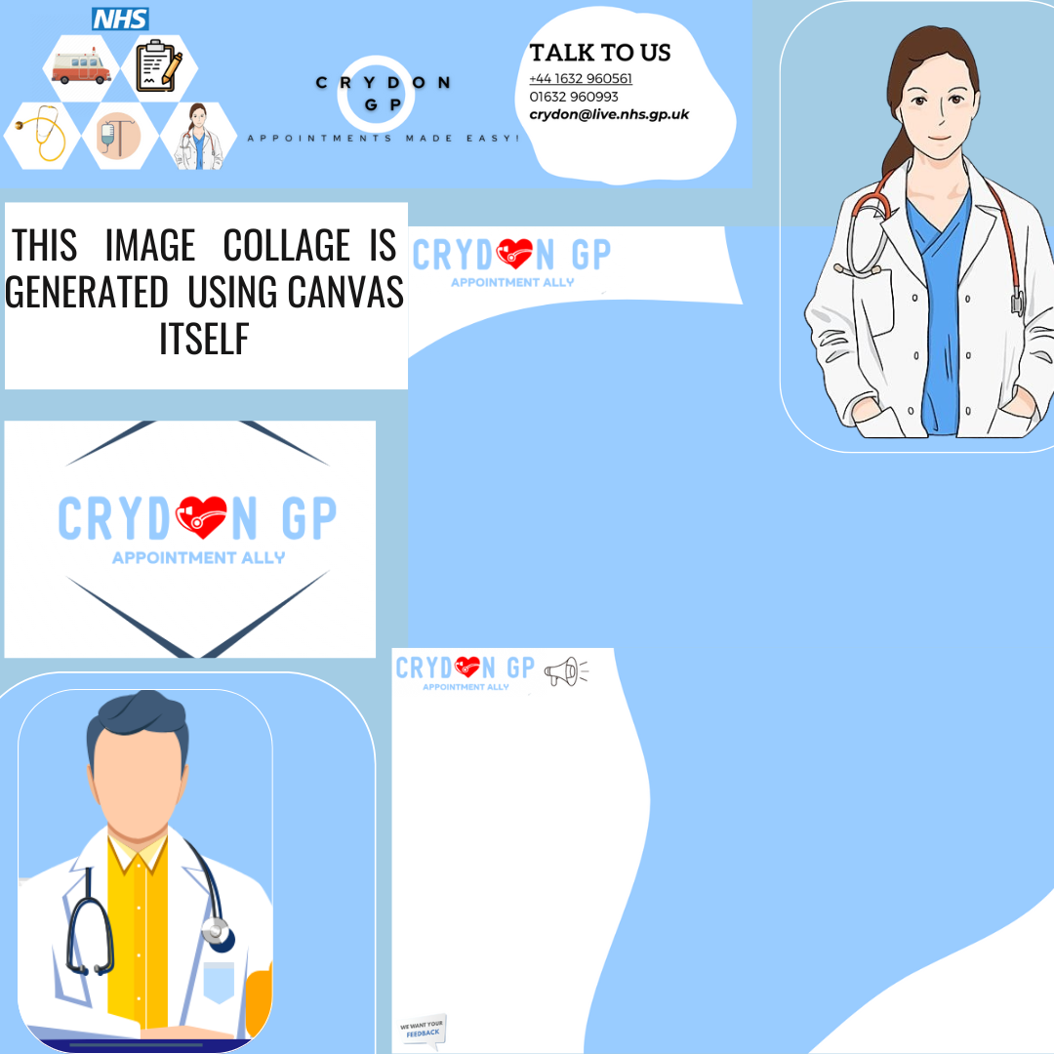

Image 1: Image Collage using Canvas

[**Looka:**](https://looka.com/)

It was utilized for logo design, offering a variety of options to select the most suitable logo after multiple drafts and feedback sessions.

 

Image 2: Final Logo

  

Image 3: Draft Logos

[**Photoresizer:**](https://www.photoresizer.com/)

It facilitated image resizing and cropping, ensuring optimal image quality without compromising resolution.

[**Lucid chart:**](https://www.lucidchart.com/)

This tool was utilized for creating most of the diagrams and figures, providing a versatile platform for precise diagramming.

[**Remove bg:**](https://www.remove.bg/)

Tools like Remove bg were employed to remove backgrounds from images swiftly.

[**Descript:**](https://www.descript.com/)

Descript was used to generate an AI video and voiceover for the app, enhancing its presentation and accessibility.

[**Asana:**](https://app.asana.com/)

Asana was used for project management. It helped to keep the track of the development and keep things organized.

[**Mendix:**](https://www.mendix.com/)

Although Mendix itself is a technology for developing web app, it is also well known for managing sprints in an easy and organized way.

**Learning Tools:**

Throughout the project, continuous learning and research were paramount, with YouTube serving as a primary source for tutorials and the Microsoft Community providing valuable assistance in troubleshooting issues encountered during development. Social communities like LinkedIn and Reddit were also used to tackle errors and/or get ideas.

In summary, these technologies collectively contributed to the successful development of the Croydon GP application, ensuring a seamless user experience and robust functionality.

### 6.4.4) Sprints

The development of the app will be organized into time-bound iterations called sprints. These sprints, usually lasting between two to four weeks, will focus on developing, testing, and releasing a set of user stories. By adopting this agile approach, the project will benefit from incremental progress and frequent user feedback, ensuring that the app evolves according to user needs and preferences. Detailed sprint plans will be outlined to facilitate effective project tracking and management. For more information, refer to Appendix A.

### 6.4.5) Asana Dashboard

The Asana tool will be utilized as part of our project management strategy. This powerful platform will enable efficient task organization, collaboration, and tracking throughout the app development process. By leveraging Asana, team members can assign tasks, set deadlines, and monitor progress in real-time, ensuring seamless coordination and timely delivery of project milestones. Integration with Asana will enhance project transparency, streamline communication, and facilitate effective project management practices (Asana, no date).

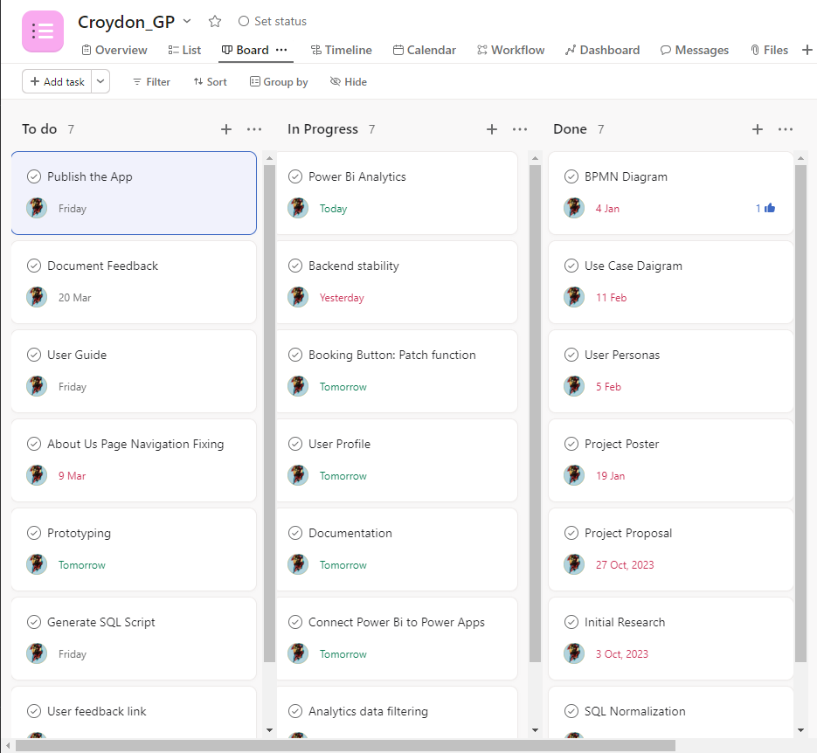

Image 4 : Asana Dashboard

### 6.4.6) Ethics Clearance

Before initiating this project, an Ethical Approval form was submitted to and reviewed by the University's School Research Ethics Committee. This thorough process ensures the prevention of any potential harm to individuals or the environment, encompassing both physical and digital realms. Beyond physical risks, such as ensuring participant safety, the committee also addresses digital threats, including data governance and security measures. The Ethics form, signed by two supervisors, was then presented to the Committee for final authorization, signifying a commitment to ethical research practices and mitigating any potential risks associated with the project.

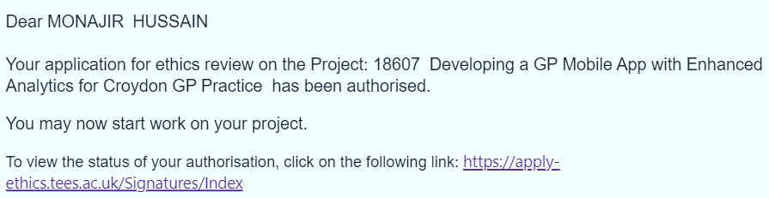

Image 5: Ethics Clearance Evidence

## 6.5) Analysis

### 6.5.1) User Persona 1

|  |  |  |
| --- | --- | --- |
|  | **Full Name** | Shabana Praveen |
| **Age** | 38 |
| **Occupation** | Auditor at Greggs |
| **Location** | Newcastle, UK |
| **Background** | Shabana is a vibrant and dynamic auditor, always on the go and looking for ways to streamline her busy life. Between managing campaigns and chasing after her energetic daughter, Shabana finds it challenging to prioritize her health and book GP appointments. |
| **Pain Points** | * Struggles to find time for GP appointments amidst hectic work schedules and family commitments. * Frustration with long wait times and limited availability at traditional GP practices. * Concerns about forgetting important medical check-ups and screenings due to her packed schedule. |
| **Goals and Needs** | Shabana dreams of a GP Web app that fits seamlessly into her fast-paced lifestyle. She envisions a user-friendly platform that offers flexible appointment booking, instant reminders, and easy access to medical records. Shabana hopes to find a digital healthcare solution that empowers her to take control of her well-being without sacrificing precious time with her family. |

Table 1: User Persona 1

### 6.5.2) User Persona 2

|  |  |  |
| --- | --- | --- |
|  | **Full Name** | David Thompson |
| **Age** | 71 |
| **Occupation** | Retired Teacher |
| **Location** | Middlesbrough, UK |
| **Background** | David is a beloved retired teacher and a neighbour known for his kindness and community spirit. As he gracefully embraces his senior years, David focuses on maintaining his health and staying active in his neighbourhood. However, mobility issues and the challenges of aging make it difficult for David to access traditional healthcare services. |
| **Pain Points** | * Struggles with mobility issues and limited transportation options to travel to GP practices. * Frustration with long wait times and impersonal care at overcrowded clinics. * Desires more personalized attention and support from healthcare providers as he navigates his golden years. |
| **Goals and Needs** | David envisions a GP app that caters to his unique needs and offers tailored healthcare solutions. He dreams of virtual consultations, home visit options, and medication reminders to simplify his healthcare routine. David hopes to find a compassionate and caring digital platform that honours his contributions to the community and supports him in living life to the fullest. |

Table 2: User Persona 2

### 6.5.3) User Persona 3

|  |  |  |
| --- | --- | --- |
|  | **Full Name** | Bipul Bhatta |
| **Age** | 22 |
| **Occupation** | Freelance Graphic Designer |
| **Location** | Middlesbrough, UK |
| **Background** | Bipul is a free-spirited graphic designer with a passion for creativity and self-expression. He thrives in the fast-paced world of freelance work, constantly seeking inspiration and pushing the boundaries of design. Despite his artistic pursuits, Bipul values his health and seeks proactive ways to stay well and balanced. |
| **Pain Points** | * Struggles to carve out time for GP appointments amidst tight project deadlines and creative bursts. * Frustration with outdated healthcare services that lack digital innovation and modern conveniences. * Desires personalized and proactive healthcare recommendations tailored to his unique lifestyle and creative energy. |
| **Goals and Needs** | Bipul dreams of a GP app that reflects his artistic spirit and offers innovative solutions to his healthcare needs. He envisions a platform that combines aesthetic appeal with practical functionality and wellness resources. Bipul hopes to find a digital companion that supports his holistic well-being and encourages him to thrive in both his professional and personal endeavours. |

Table 3: User Persona 3

## 6.6) Requirements & Features List

Requirement and Feature List for the GP Web app:

**1. Signup:**

- Requirement: Users should be able to create a new account to access the app's features.

- Features:

- User registration form with fields for name, email, and password.

- Email verification for account activation.

- Option for social media login (e.g., Github, Facebook).

**2. Login:**

- Requirement: Registered users should be able to log in securely to access their account.

- Features:

- Secure login functionality with email and password.

- Option for biometric authentication (e.g., fingerprint, Face ID).

**3. Create a User:**

- Requirement: Admins should have the ability to create user accounts on behalf of patients or healthcare providers.

- Features:

- Admin dashboard with user management capabilities.

- Form to input user details such as name, email, and role (patient or healthcare provider).

**4. Reset Password:**

- Requirement: Users should have the ability to reset their password if forgotten or compromised.

- Features:

- Password reset functionality via email verification.

- Security questions or OTP (one-time password) verification for identity confirmation.

**5. Home Screen:**

- Requirement: Users should have access to a central dashboard providing an overview of essential app features and information.

- Features:

- Personalized home screen displaying upcoming appointments, recent activity, and health insights.

- Quick access buttons for common actions such as booking appointments and viewing medical records.

**6. Book an Appointment:**

- Requirement: Users should be able to schedule appointments with healthcare providers conveniently.

- Features:

- Calendar view for selecting appointment dates and times.

- Search functionality to find available healthcare providers based on specialty, location, or availability.

- Confirmation notifications for successfully booked appointments.

**7. Manage the Appointment:**

- Requirement: Users should be able to view, edit, or cancel their scheduled appointments.

- Features:

- Appointment management dashboard displaying upcoming and past appointments.

- Option to reschedule or cancel appointments with appropriate notifications sent to both user and provider.

**8. Analytics Page:**

- Requirement: Admins should have access to analytics and insights on appointment bookings, user activity, and service usage.

- Features:

- Analytics dashboard with graphical representations of key metrics such as appointment volume, missed appointments, and user engagement.

- Customizable reporting tools for generating detailed analytics reports based on specific criteria.

**9. About Us Page:**

- Requirement: Users should have access to information about the app, its creators, and its mission.

- Features:

- About Us section providing background information on the app's development team, objectives, and values.

- Mission statement highlighting the app's commitment to improving healthcare access and delivery.

**10. Contact Us Page:**

- Requirement: Users should have a way to reach out to app administrators for support or inquiries.

- Features:

- Contact Us form allowing users to submit queries, feedback, or support requests.

- Direct contact information for customer support channels such as email, phone, or live chat.

This requirement and feature list outlines the key functionalities necessary for the GP Web app to deliver a seamless and efficient user experience for both patients and healthcare providers.

## 6.7)User Experience/User Interface

In the development of the Croydon GP web application, fundamental principles of user interface (UI) and user experience (UX) design are adhered to, ensuring a seamless, intuitive, and user-centric platform. The approach begins with a strong emphasis on user-cantered design, where prioritization is given to understanding the needs, preferences, and behaviours of the target audience. Comprehensive user research, including surveys, feedbacks, and usability testing, provides valuable insights that inform every aspect of the platform's design and functionality.

Wong(2021) says, consistency is another key principle that guides the design process. Maintaining consistency in visual elements, interaction patterns, and navigation structures fosters familiarity and predictability for users. Established design standards and conventions are adhered to, creating a cohesive and unified user experience across the platform.

Simplicity is paramount in the design philosophy (YellowKE, 2023). Unnecessary clutter and complexity are removed to streamline user interactions and minimize cognitive load. Focus is placed on essential features and functionalities to ensure that users can accomplish their tasks efficiently and effectively.

Accessibility is a core principle that underscores the commitment to inclusivity. The platform is designed to be accessible to individuals of all abilities, incorporating features such as alternative text for images, keyboard navigation support, and optimized screen reader compatibility. Prioritizing accessibility ensures that everyone can access and use the platform with ease (Scope, 2022).

Feedback and affordance play a crucial role in guiding users through the platform's interface. Clear and timely feedback to user actions, using visual cues, animations, and error messages, enhances usability and learnability. Affordances are leveraged to intuitively communicate the functionality of interactive elements, further improving the user experience (TMDesign, 2023).

Throughout the project development, these principles are rigorously followed, integrating them into every stage of the design and development process. From initial concept ideation to final implementation, design decisions are continuously evaluated against these principles, iterating and refining the platform to deliver an exceptional user experience. Adherence to these fundamental principles of UI/UX design ensures that the Croydon GP web application meets the needs and expectations of users, ultimately enhancing their satisfaction and engagement with the platform.

## 6.8) Competitor Analysis and Adaptations

This section delves into existing applications within the healthcare sector that bear resemblance to the Croydon GP app. By conducting a thorough analysis of competitors, valuable insights are gained into market trends and user preferences. From this exploration, the team can adapt and innovate, enhancing the app to better meet user needs and stand out in the competitive landscape (Silva, C. & Paruch, Z., 2023).

|  |  |  |  |  |  |
| --- | --- | --- | --- | --- | --- |
|  | Competitor A | Competitor B | Competitor C | Competitor D | Proposed App |
| Overview | | | | | |
| Name | Setmore appointments Scheduling | tapGP: Online GP appointments | Booking System | Dr.Book | Croydon GP |
| Developer | Setmore | tapGP | Gunia UG | Lee Kelly for Teesside University | MD Monajir Hussain for Teesside University |
| Description | This is a simple to use general appointment booking app which allows user to have access to a calendar so that user can quickly schedule appointments. | This allows users to book appointments for a £39 fee to speak to a doctor through the app. User can also access their prescriptions and other medical notes issued to them. | This app allows user to set up a quick booking system allowing them to send a link to clients so that they can book appointments. | This app allows users to search, view and edit health appointments in a simple, easy to use and visually pleasing app featuring a home, news and doctors page. | This app will aims to be user friendly with features such as such as appointment scheduling, and personalized patient profiles. |
| Fee | Free | Free | Free | Free(With Power Apps Account) | Free(With Power Apps Account) |
| Subscription fee? | Yes | No | Yes | No | No |
| Platform | IOS/Android | IOS/Android | IOS/Android | Power Apps App List | Power Apps App List |
| App store Rating | 4.4/5 | 4.8/5 | 4.3/5 | Not Launched Online | Not Launched Online |
| Features | | | | | |
| Summary of Main Features | * Calendar * View appointment details * View Customer Information * Activities Tab | * Select a slot for a telephone appointment * View booked appointments * Change reservation of appointments | * List of all appointments-available and booked * Allows to set a duration * Link to form for users * Admin/Users only areas | * Login/Sign Up * Booked appointments * Search, filter, sort appointments * Doctor Information * Newsfeed tab | * Login/Sign Up * Reset password * Book appointments * Manage appointments * Receive email reminders * App video and information in About Us page * Easy Navigation * Admin Only Area * Feedback Area for users |
| Booking Layout | Calendar or List | List | List | List | List |
| Ease of Use | Great | Good | Okay | Great | Should be Great |
| User Experience | Good- Logical Layout | Good- Simple to use | Bad- Hard to Navigate | Great- Modern and logical layout | Should be Great: User-friendly and easy Navigation |
| Strengths | Easy to use and has a nice layout. Share booking page easily | Simple to use | Straight forward booking system | Amazing app with an inclusive design | Should be user-friendly with easy bookings and their management |
| Weaknesses | No customization available for booking page design | Long booking process | Limited customization for users available | Limited features and no online hosting, and Domain name | Features may be limited due to time constraints and skills |
| Personal Rating | 7.5/10 | 6.5/10 | 5/10 | 7.5/10 | N/A |

Table 4: Competitive Analysis

# Issues and Considerations

Considering legal, security, and social/ethical considerations is crucial in the development of the Croydon GP app. These factors not only ensure compliance with relevant laws and regulations but also safeguard user privacy, data security, and ethical principles. Addressing legal considerations helps mitigate legal risks and ensures that the app operates within the bounds of the law, protecting both users and the organization from potential legal liabilities (GDPR, 2021). Security considerations are paramount in safeguarding sensitive user data from unauthorized access or breaches, thereby fostering trust and confidence among users. Additionally, social and ethical considerations promote inclusivity, transparency, and ethical use of data, fostering a positive user experience and reinforcing the app's reputation as a trusted healthcare solution (Hussain,A., 2021). By prioritizing these factors, the Croydon GP app can effectively navigate legal complexities, mitigate security risks, and uphold ethical standards, ultimately enhancing user trust, satisfaction, and overall success of the app.

## 7.1)Legal Considerations:

* Compliance with Data Protection Regulations: Ensuring that the app complies with data protection laws such as GDPR (General Data Protection Regulation) to safeguard user privacy and data security (GDPR, 2021).
* Intellectual Property Rights: Awareness of intellectual property laws to avoid infringing on patents, trademarks, or copyrights of other entities during app development.
* Healthcare Regulations: Adherence to healthcare regulations and standards to ensure the app's compliance with relevant legal frameworks governing healthcare services and patient data.

## 7.2)Security Considerations:

* Data Encryption: Implementation of robust encryption protocols to protect sensitive user data, such as personal health information, from unauthorized access or breaches (Malbrough, 2023).
* Secure Authentication Mechanisms: Incorporation of secure authentication methods, such as OTP mechanism, to prevent unauthorized access to user accounts and sensitive app functionalities (MiniOrange, 2023).
* Regular Security Audits: Conducting routine security audits and vulnerability assessments to identify and address potential security weaknesses or loopholes in the app's infrastructure.
* Secure Data Storage: Employing secure data storage practices, including secure cloud storage solutions and regular data backups, to prevent data loss or compromise (Kirvan et al., 2024).

## 7.3)Social & Ethical Considerations:

* Accessibility: Ensuring that the app is accessible to individuals with disabilities by following accessibility guidelines and incorporating features such as screen readers and alternative input methods (Henry et al., 2016).
* Equity and Inclusivity: Designing the app to be inclusive and accessible to users from diverse backgrounds, cultures, and socioeconomic statuses, thereby promoting equity in healthcare access (Henry et al., 2016).
* Transparency and Informed Consent: WebDesign (no date) states, “Providing clear and transparent information to users about data collection, usage, and sharing practices, and obtaining informed consent from users before collecting their personal information”.
* Ethical Use of Data: Ensuring that user data is used ethically and responsibly, with measures in place to prevent misuse or exploitation of sensitive information for commercial or unethical purposes.

# 8) Design

## 8.1) Mood Board

The following colour scheme/palette will be used throughout the branding and application / user interface.

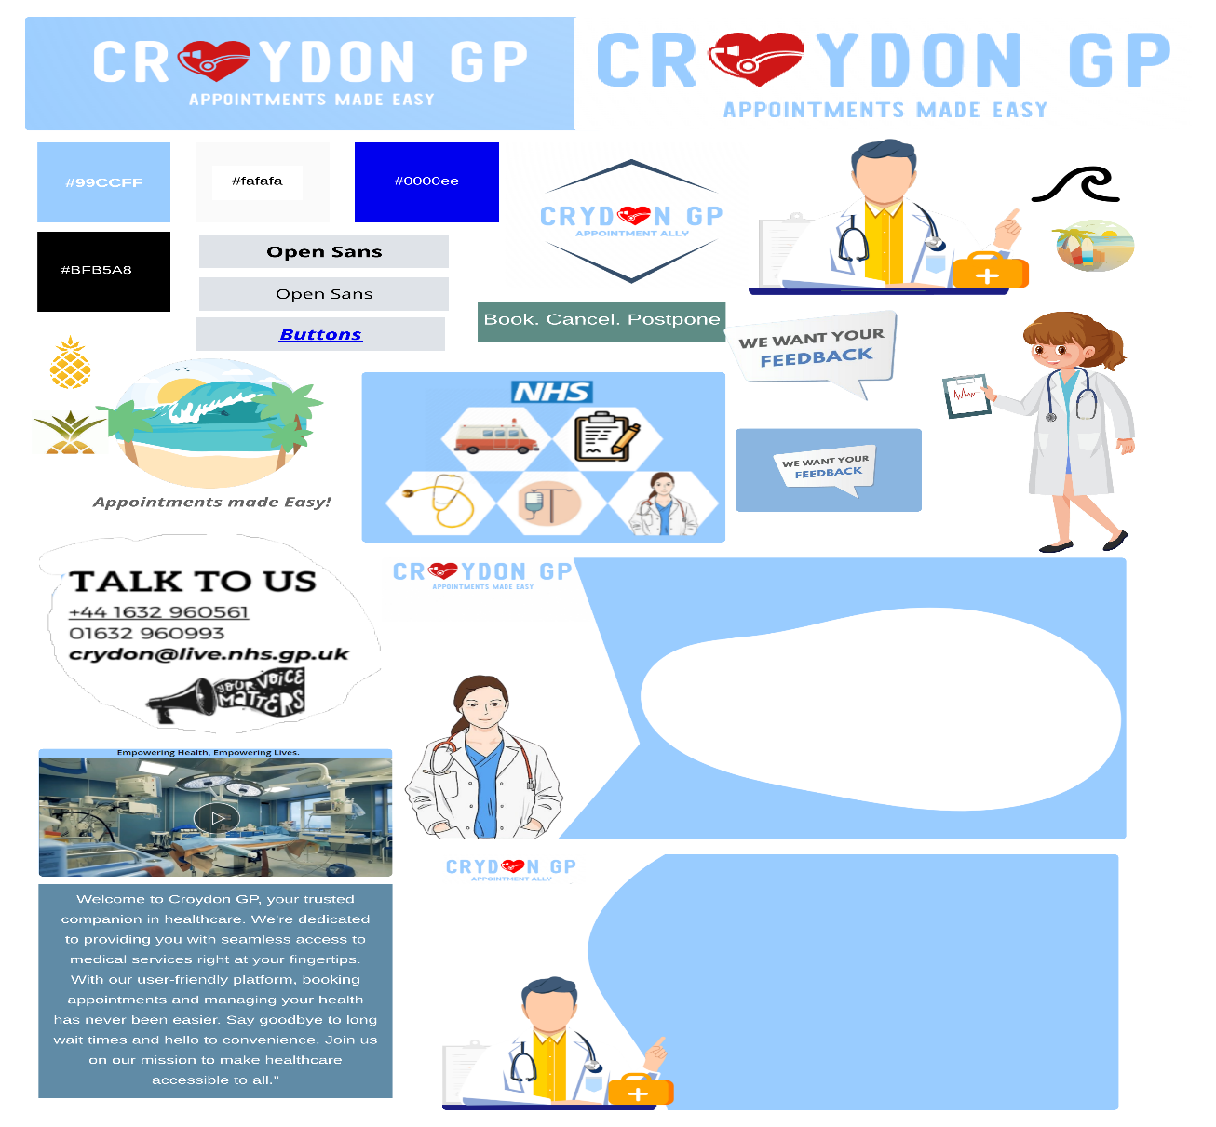

Image 6: Mood Board

Croydon GP app boasts a clean, modern design with a soothing colour palette that promotes a sense of calm and trust. It is believed that a visually appealing interface enhances the overall user experience, and the apps’ theme reflects its commitment to create a welcoming environment for patients.

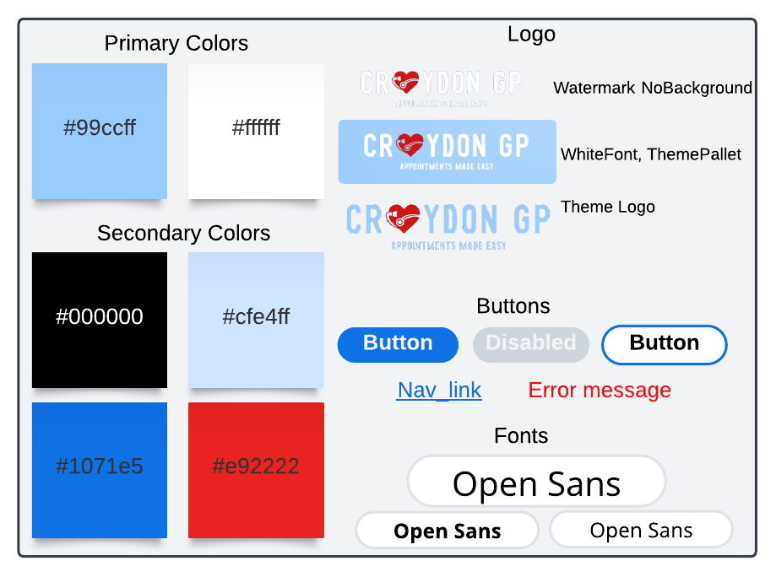

Image 7: House style

Before the commencement of app development, preliminary steps were taken to conceptualize its design and style. This included the creation of mood boards and house styles. Prior to these, brainstorming sessions involved doodling ideas and thoughts on paper in real-time, capturing the flow of creativity. The initial planning phase involved jotting down key notes and sketches, as depicted in the provided images below.

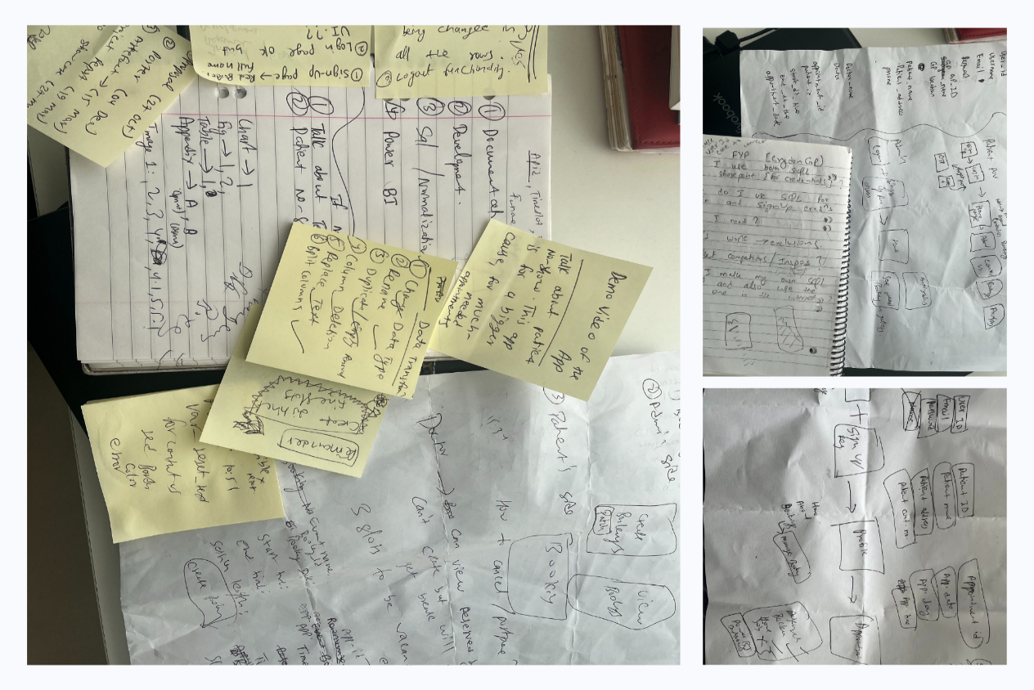

Image 8: Preliminary Planning Sketches

## 8.2) App Design

The Croydon GP app is designed with user-friendliness in mind, featuring intuitive navigation that ensures seamless exploration. Whether a user is booking an appointment, checking their health records, or providing feedback, they will find it all just a few taps away.

### 8.2.1) Use Case Diagram

The use case diagram illustrates the various interactions between users and the Croydon GP application, outlining the core functionalities and user roles within the system.

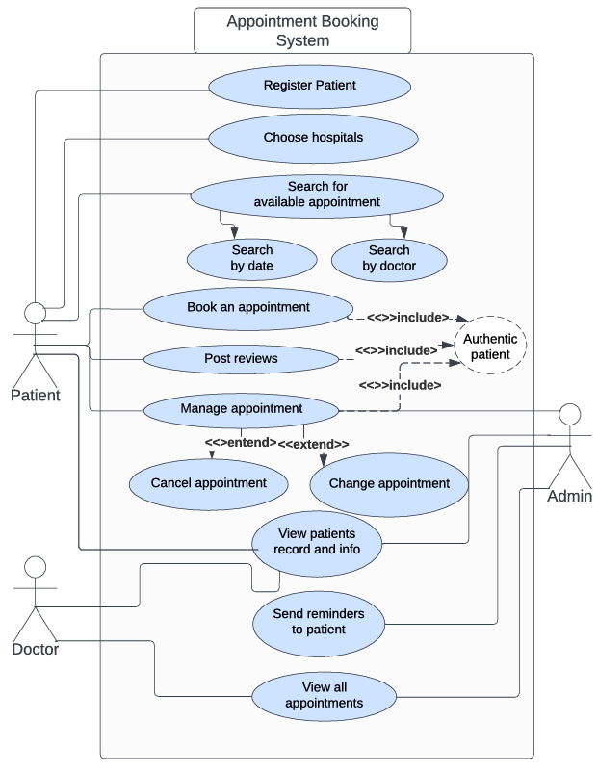

Figure 2: Use Case Diagram

### 8.2.2) BPMN Diagram

The BPMN diagram visually represents the business processes and workflows within the Croydon GP application, providing a comprehensive overview of the system's operations. Its use proved instrumental in mapping out the various functionalities and potential interactions, aligning with industry standards and best practices for efficient process design.

The below diagram shows how a user can sign up and/or log in into the Croydon GP app. And all the process involved in booking and managing their appointments.

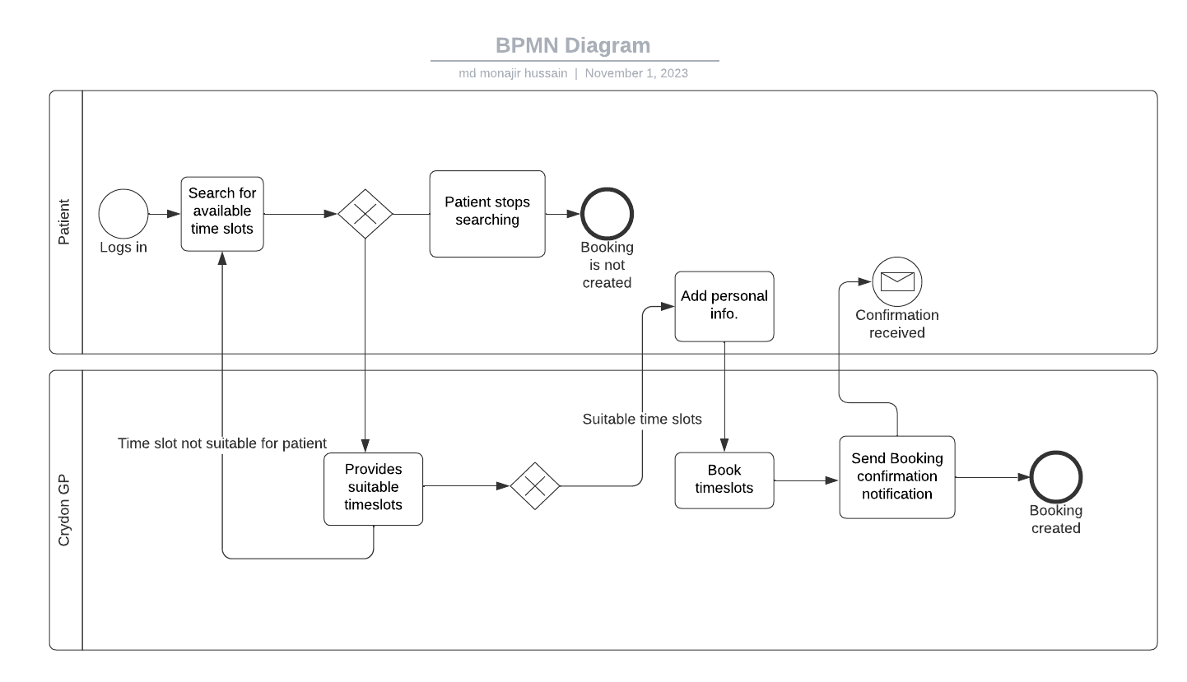Figure 3 : BPMN Diagram

### 8.2.3) CRUD Matrix (Create, Read Update and Delete Table)

The CRUD matrix outlines the fundamental operations - Create, Read, Update, and Delete - that can be performed on data entities within the Croydon GP application. This matrix serves as a valuable reference, detailing the permissions and access levels associated with each operation for different user roles. By clearly defining these CRUD operations, the matrix ensures proper data management and security protocols are upheld throughout the application's development and usage phases.

|  |  |  |  |
| --- | --- | --- | --- |
|  | **Patients** | **GP Practitioners** | **Administrator** |
| **Sign up** | |  |  | | --- | --- | | C |  | |  |  | | |  |  | | --- | --- | | C |  | |  |  | | |  |  | | --- | --- | | C |  | |  |  | |
| **Reset Password** | |  |  | | --- | --- | |  |  | | U |  | | |  |  | | --- | --- | |  |  | | U |  | | |  |  | | --- | --- | | C | R | | U | D | |
| **Update User Contact Details** | |  |  | | --- | --- | |  | R | | U | D | | |  |  | | --- | --- | |  | R | |  |  | | |  |  | | --- | --- | | C | R | | U | D | |
| **User Accounts** | |  |  | | --- | --- | |  |  | |  |  | | |  |  | | --- | --- | |  |  | |  |  | | |  |  | | --- | --- | | C | R | | U | D | |
| **Home** | |  |  | | --- | --- | |  | R | |  |  | | |  |  | | --- | --- | |  | R | |  |  | | |  |  | | --- | --- | |  | R | | U |  | |
| **User Profile** | |  |  | | --- | --- | |  | R | | U |  | | |  |  | | --- | --- | |  | R | |  |  | | |  |  | | --- | --- | | C | R | | U | D | |
| **About page** | |  |  | | --- | --- | |  | R | |  |  | | |  |  | | --- | --- | |  | R | |  |  | | |  |  | | --- | --- | |  | R | |  |  | |
| **Available Appointments** | |  |  | | --- | --- | |  | R | |  |  | | |  |  | | --- | --- | |  | R | |  | D | | |  |  | | --- | --- | | C | R | |  | D | |
| **Book Available Appointments** | |  |  | | --- | --- | |  | R | | U |  | | |  |  | | --- | --- | |  | R | |  |  | | |  |  | | --- | --- | |  | R | | U |  | |
| **All Bookings** | |  |  | | --- | --- | |  | R | | U |  | | |  |  | | --- | --- | |  | R | |  |  | | |  |  | | --- | --- | |  | R | | U |  | |
| **Create Appointments** | |  |  | | --- | --- | |  |  | |  |  | | |  |  | | --- | --- | |  | R | |  | D | | |  |  | | --- | --- | | C | R | |  | D | |
| **View All Users** | |  |  | | --- | --- | |  |  | |  |  | | |  |  | | --- | --- | |  |  | |  |  | | |  |  | | --- | --- | |  | R | |  |  | |
| **Manage Users** | |  |  | | --- | --- | |  |  | |  |  | | |  |  | | --- | --- | |  |  | |  |  | | |  |  | | --- | --- | | C | R | | U | D | |
| **Dashboard** | |  |  | | --- | --- | |  | R | |  |  | | |  |  | | --- | --- | |  | R | |  |  | | |  |  | | --- | --- | |  | R | |  |  | |
| **Database** | |  |  | | --- | --- | |  |  | |  |  | | |  |  | | --- | --- | |  |  | |  |  | | |  |  | | --- | --- | | C | R | | U | D | |

Table 5: CRUD Matrix

|  |  |
| --- | --- |
| Operations | Description |
| Create | Allows user to perform Create operation to create records |
| Read | Allows user to perform Read operation to read records |
| Update | Allows user to perform Update operation to update existing records |
| Delete | Allows user to perform Delete operation to delete existing records |
| Blank | Does not allow user to perform any operations |

Table 6: CRUD Matrix Index

### 8.2.4) Navigation Maps

The Navigation Map for the Croydon GP application outlines the user journey through the various screens and functionalities of the app. It provides a visual representation of how users can navigate from one feature to another, ensuring a seamless and intuitive experience. By mapping out the navigation flow, users can easily understand how to access different parts of the app, such as booking appointments, viewing analytics, or accessing the About Us section. This helps enhance user engagement and satisfaction by simplifying the interaction process and ensuring that users can efficiently accomplish their tasks within the app.

#### 8.2.4.1) Registered User

The below diagram is a navigation map for Patients. This navigation map shows what pages and how the user will access each page within the application.

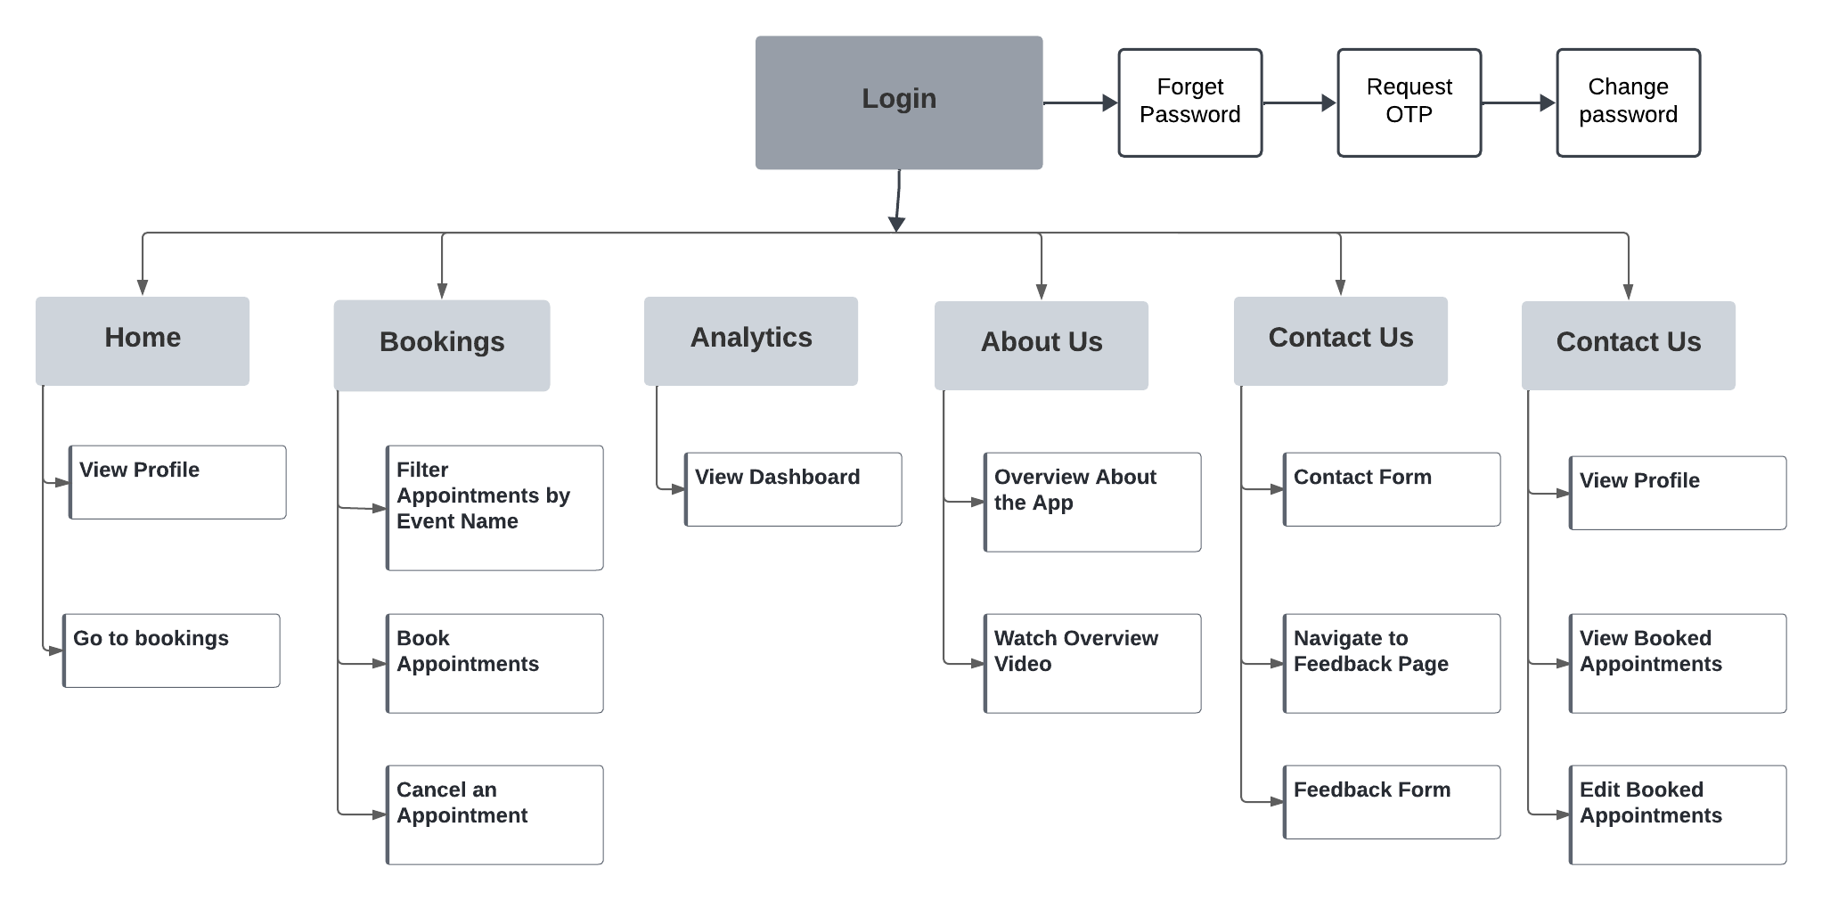

Figure 4: Patient’s Navigation Map

#### 8.2.4.2) Administrator

The below diagram is a navigation map for Admins. This navigation map shows what pages and how the admin will access each page within the application.

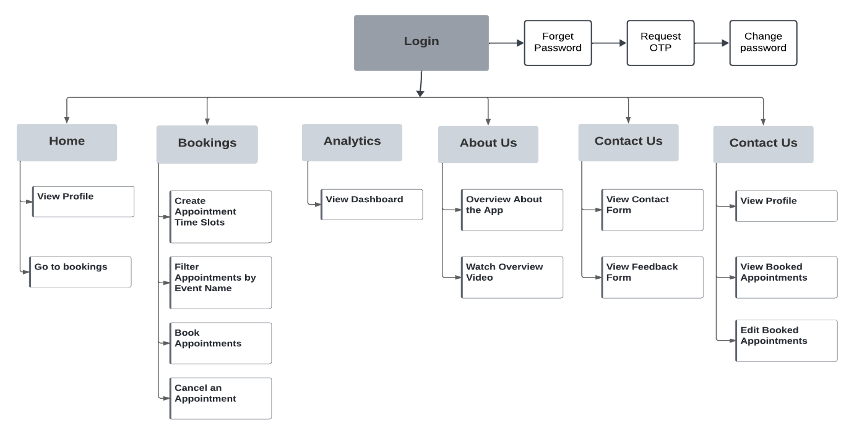

Figure 5: Admin’s Navigation Map

### 8.2.5) Wireframes

Wireframes for the Croydon GP application serve as blueprints for the app's layout and design. They provide a visual representation of each screen's structure and elements, including buttons, text fields, and images, without focusing on aesthetic details. These wireframes help in defining the app's functionality and user flow, allowing stakeholders to understand the app's structure and features early in the development process. By creating wireframes, the development team can gather feedback, make necessary adjustments, and ensure that the final product meets user needs and expectations effectively (IxDF, 2016).

#### 8.2.5.1)Home Page

The below figure is an illustration of the layout and design of the Home page for the application.

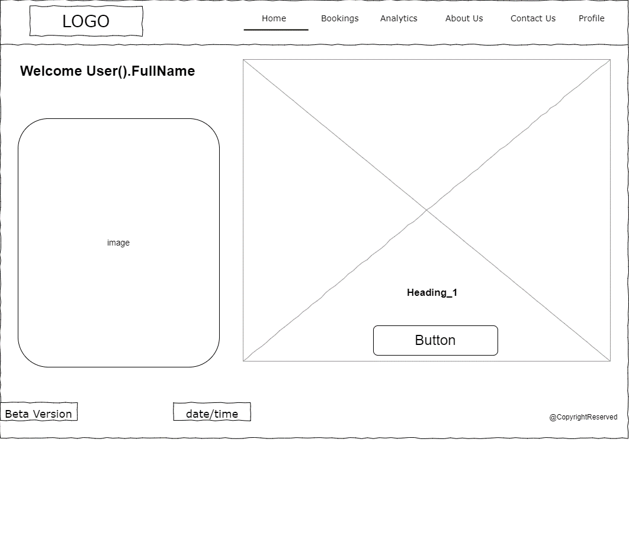

Figure 6: Wireframe(Home Page)

#### 8.2.5.2)About Us Page

The below figure is an illustration of the layout and design of the About Us page for the application.

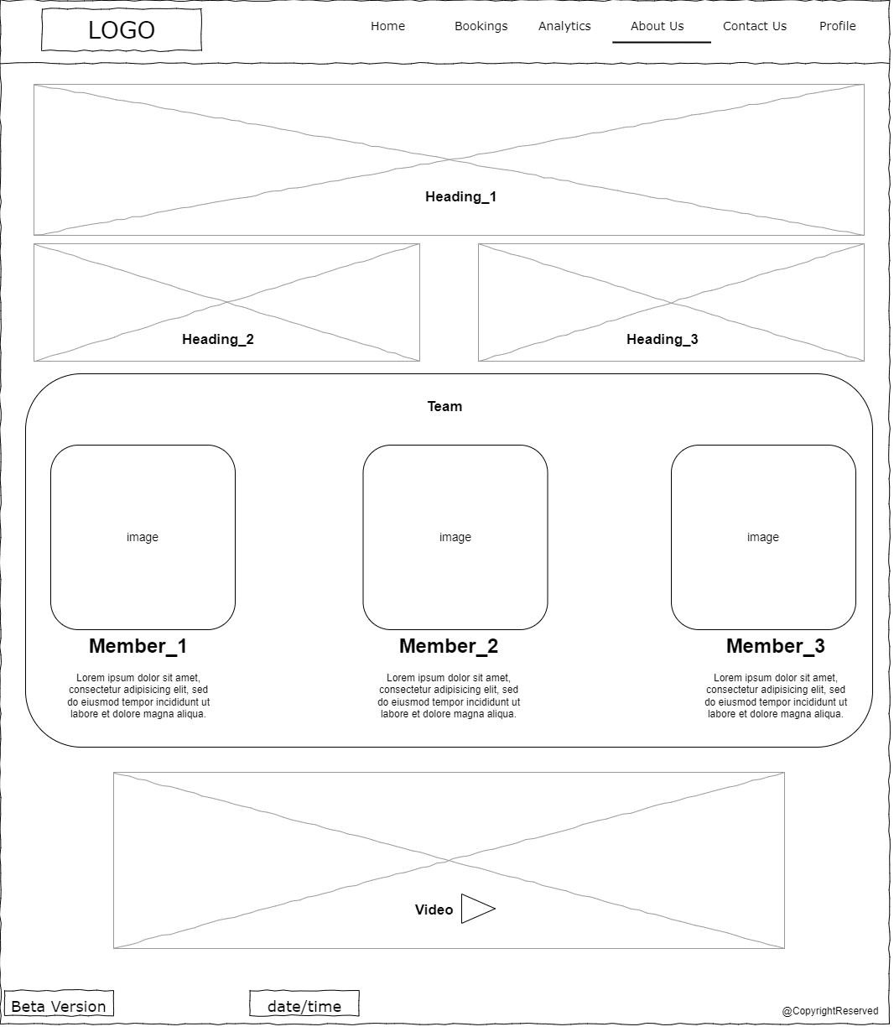

Figure 7: Wireframe(About Us Page)

#### 8.2.5.3)Booking Page for User

The below figure is an illustration of the layout and design of the Bookings page for user in the application.

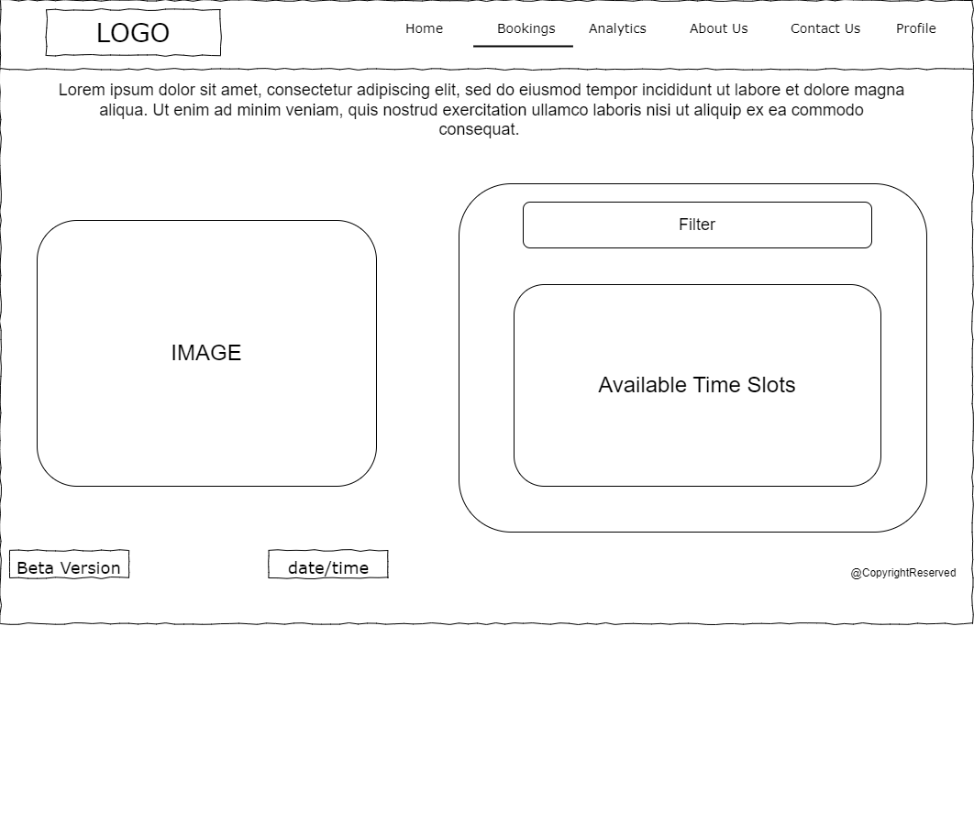

Figure 8: Wireframe(User Booking Page)

#### 8.2.5.4)Create Booking Page for Admin

The below figure is an illustration of the layout and design of the Bookings page for Admin to create different time slots in the application.

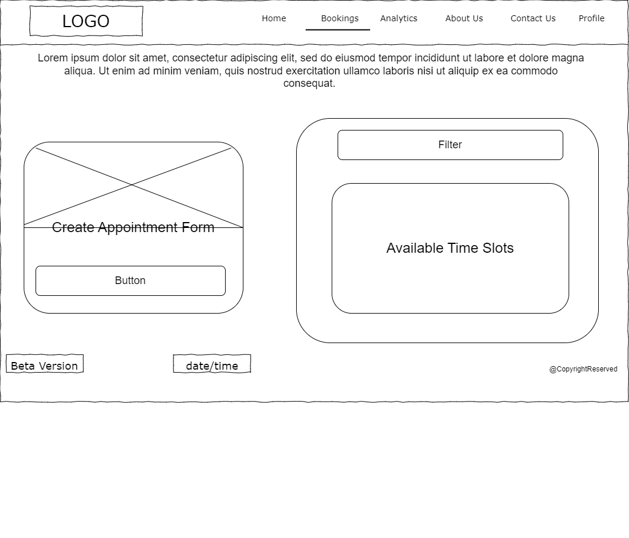

Figure 9: Wireframe(Admin Booking Page)

#### 8.2.5.5)Analytics Page

The below figure is an illustration of the layout and design of the Analytics page in the application.

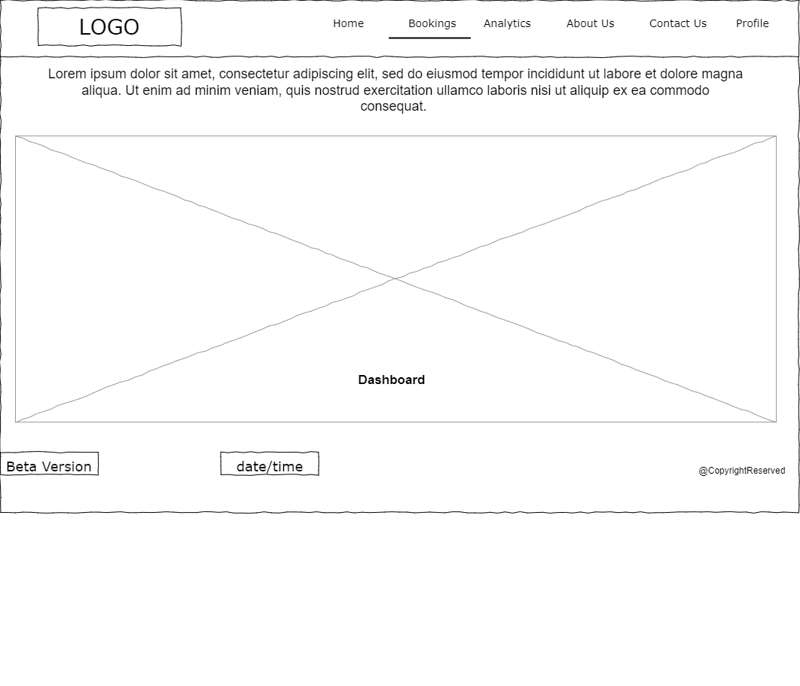

Figure 10: Wireframe(Analytics Page)

#### 8.2.5.6)Contact Us Page

The below figure is an illustration of the layout and design of the Contact Us page in the application.

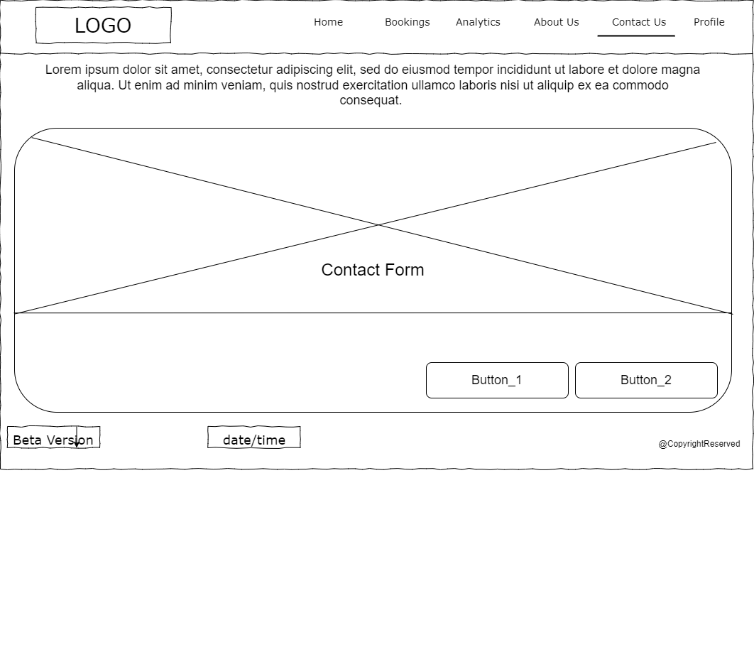

Figure 11: Wireframe(Contact Us Page)

#### 8.2.5.7)Profile Page

The below figure is an illustration of the layout and design of the Profile page in the application.

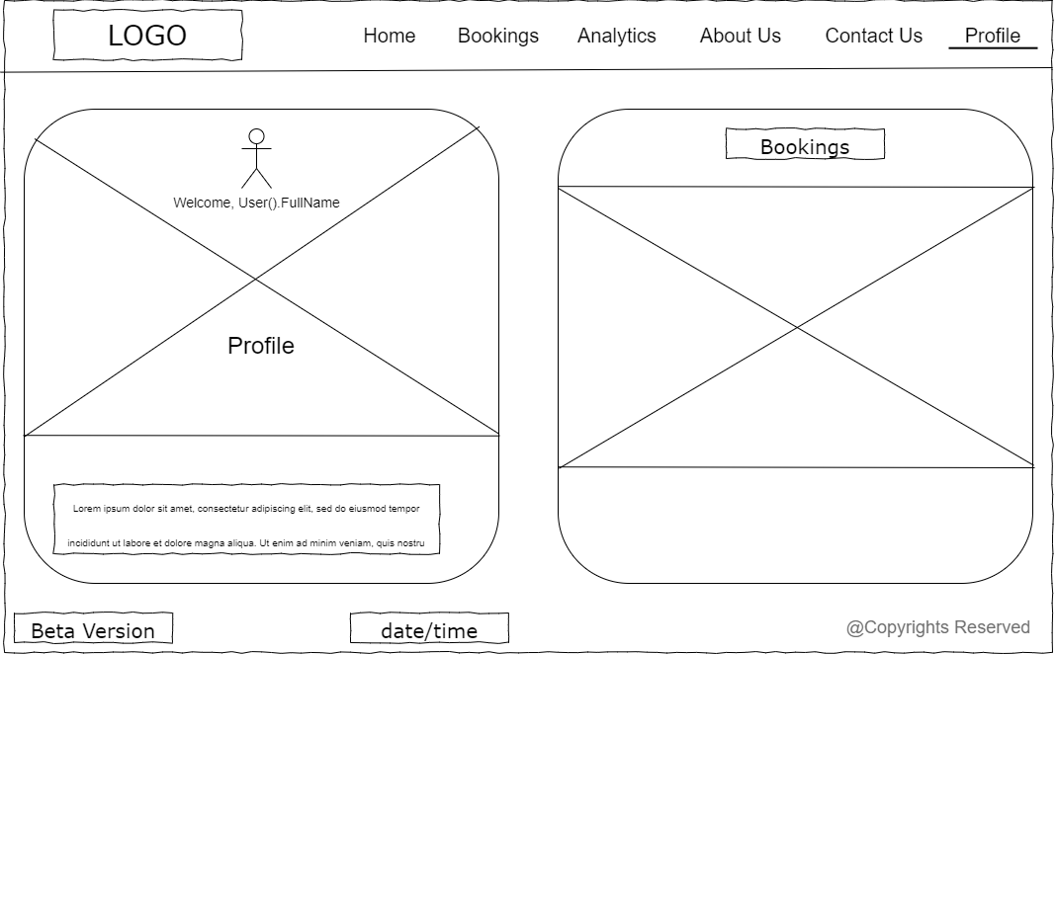

Figure 12: Wireframe(Profile Page)

#### 8.2.5.8)Sign Up/ Log In Page

The below figure is an illustration of the layout and design of the Sign Up and/or Log In page in the application.

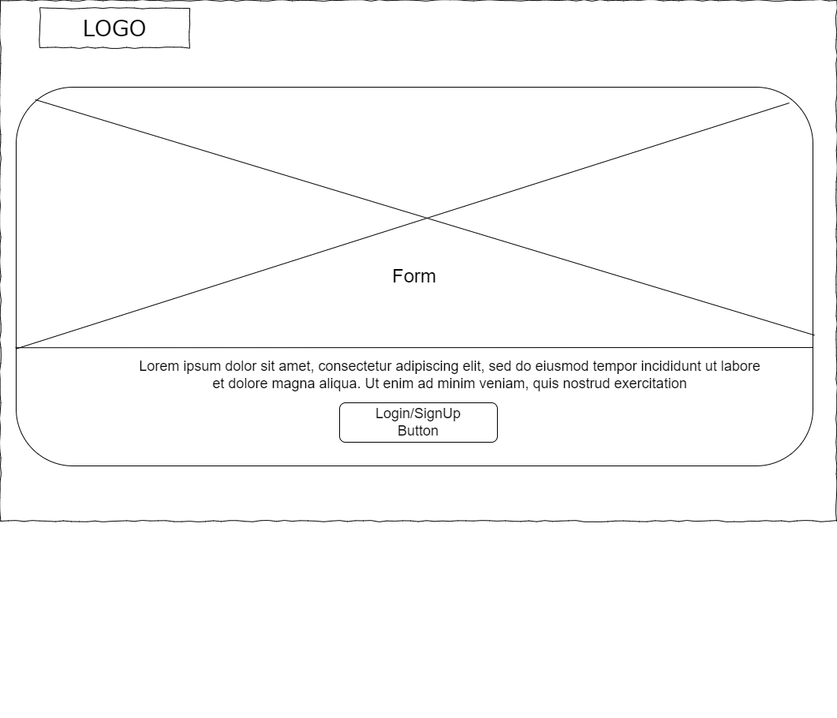

Figure 13: Wireframe(Signup/login Page)

### 8.2.6) Prototype

The prototype for the Croydon GP application is an interactive mock-up that simulates the app's functionality and user interface. It allows users and stakeholders to navigate through the app and interact with its features as if it were a real application. Prototyping helps in validating design decisions, testing usability, and gathering feedback from users before investing time and resources into full-scale development. By visualizing the app's behaviour and user experience early on, the prototype ensures that the final product meets user expectations and requirements effectively (IxDF, 2019).

#### 8.2.6.1) Log In Page

The below figure is an illustration of the prototype of the Log In page in the application.

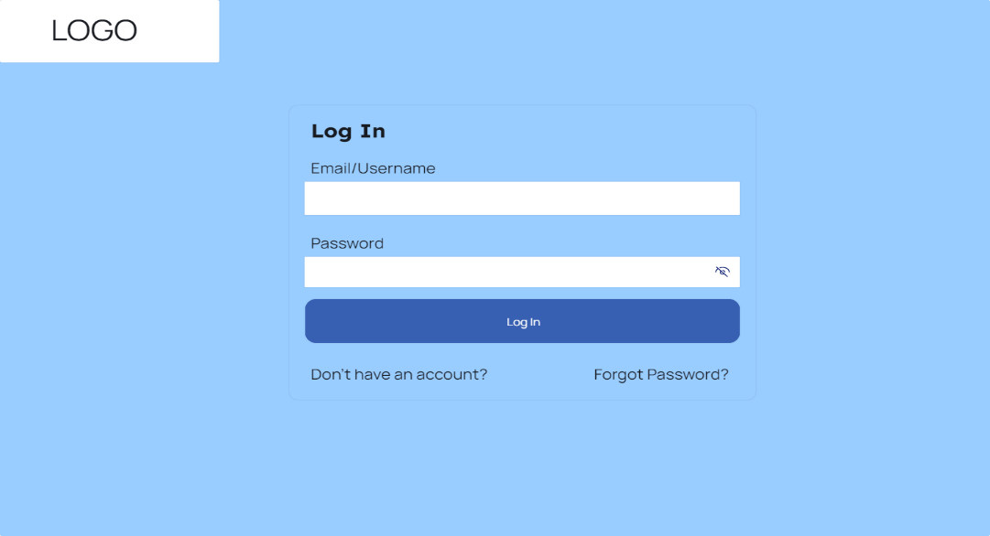

Figure 14: Prototype(Log In Page)

#### 8.2.6.2) Sign Up Page

The below figure is an illustration of the prototype of the Sign Up page in the application.

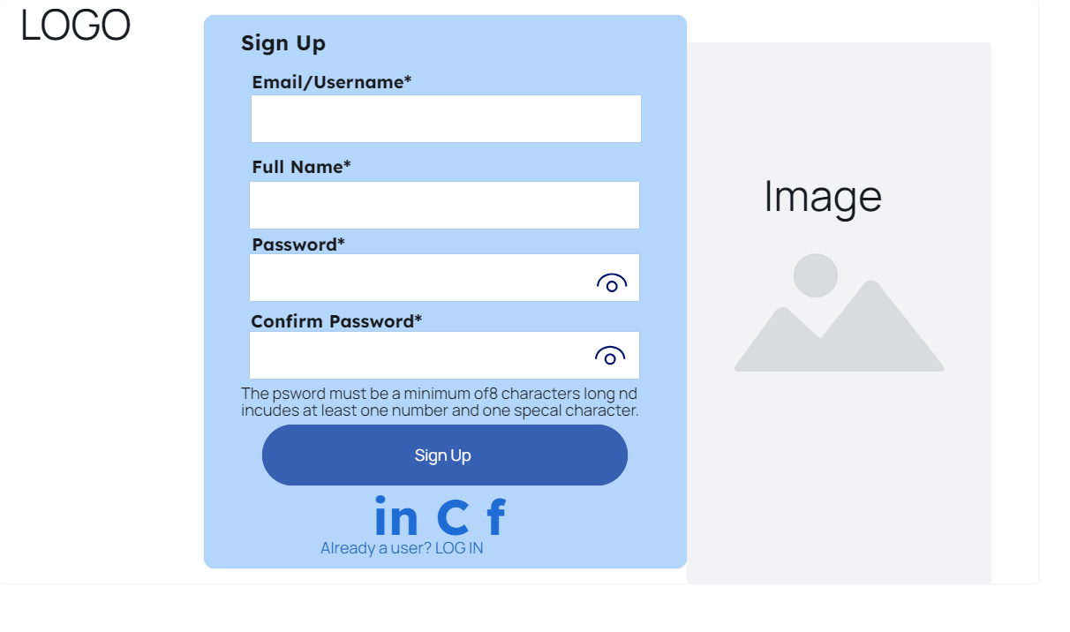

Figure 15: Prototype(Sign Up Page)

#### 8.2.6.3) Home Page

The below figure is an illustration of the prototype of the Home page in the application.

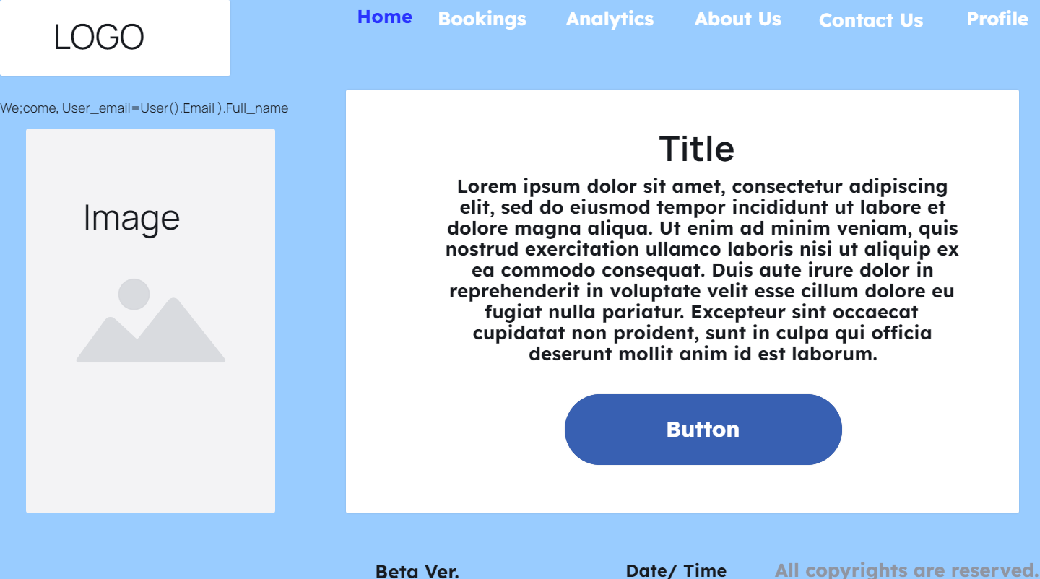

Figure 16: Prototype(Home Page)

#### 8.2.6.4) User Booking Page

The below figure is an illustration of the prototype of the Bookings page for users in the application.

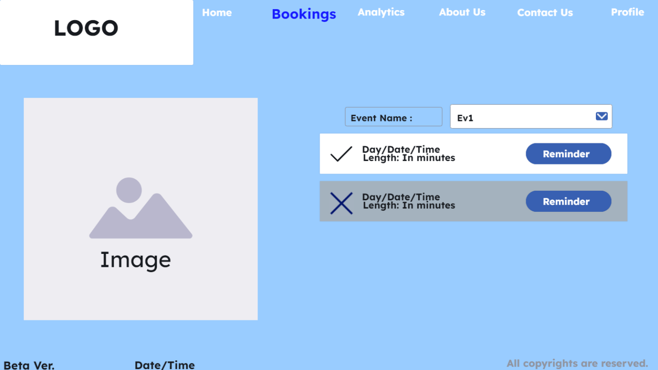

Figure 17: Prototype(User Booking Page)

#### 8.2.6.5) Create Bookings Page

The below figure is an illustration of the prototype of the Booking page for the admin to create and book time slots in the application.

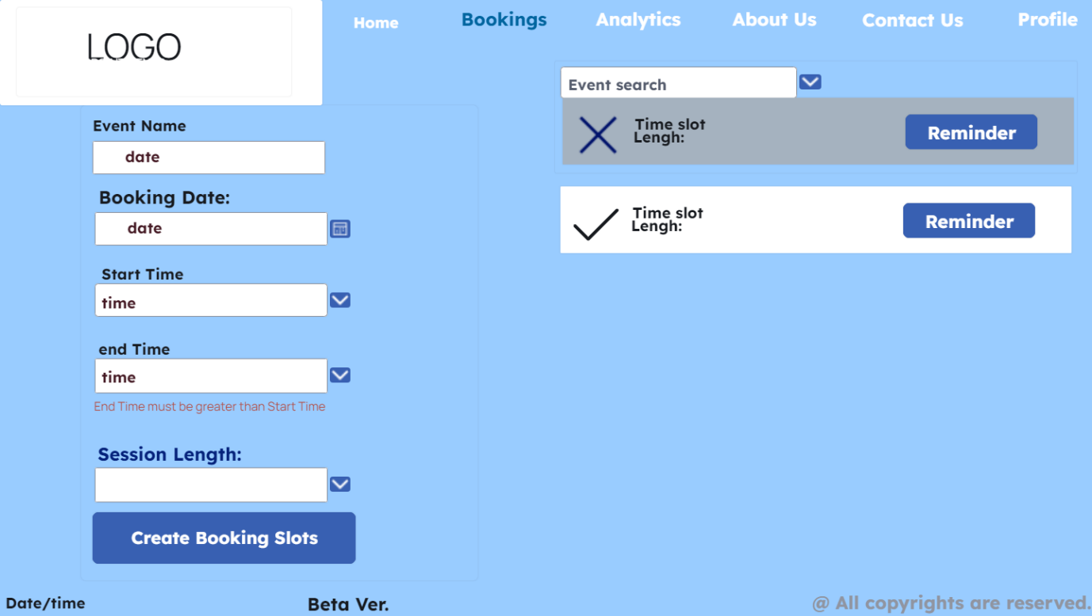

Figure 18: Prototype(Create Booking Page)

#### 8.2.6.6) About Us Page

The below figure is an illustration of the prototype of the About Us page in the application.

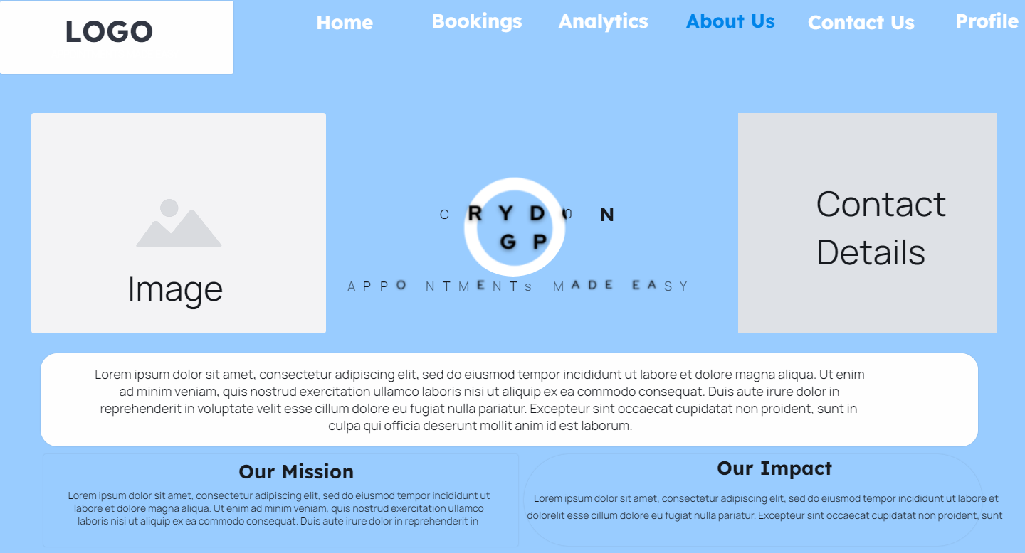

Figure 19: Prototype(About Us Page)

#### 8.2.6.7) Analytics Page

The below figure is an illustration of the prototype of the Analytics page in the application.

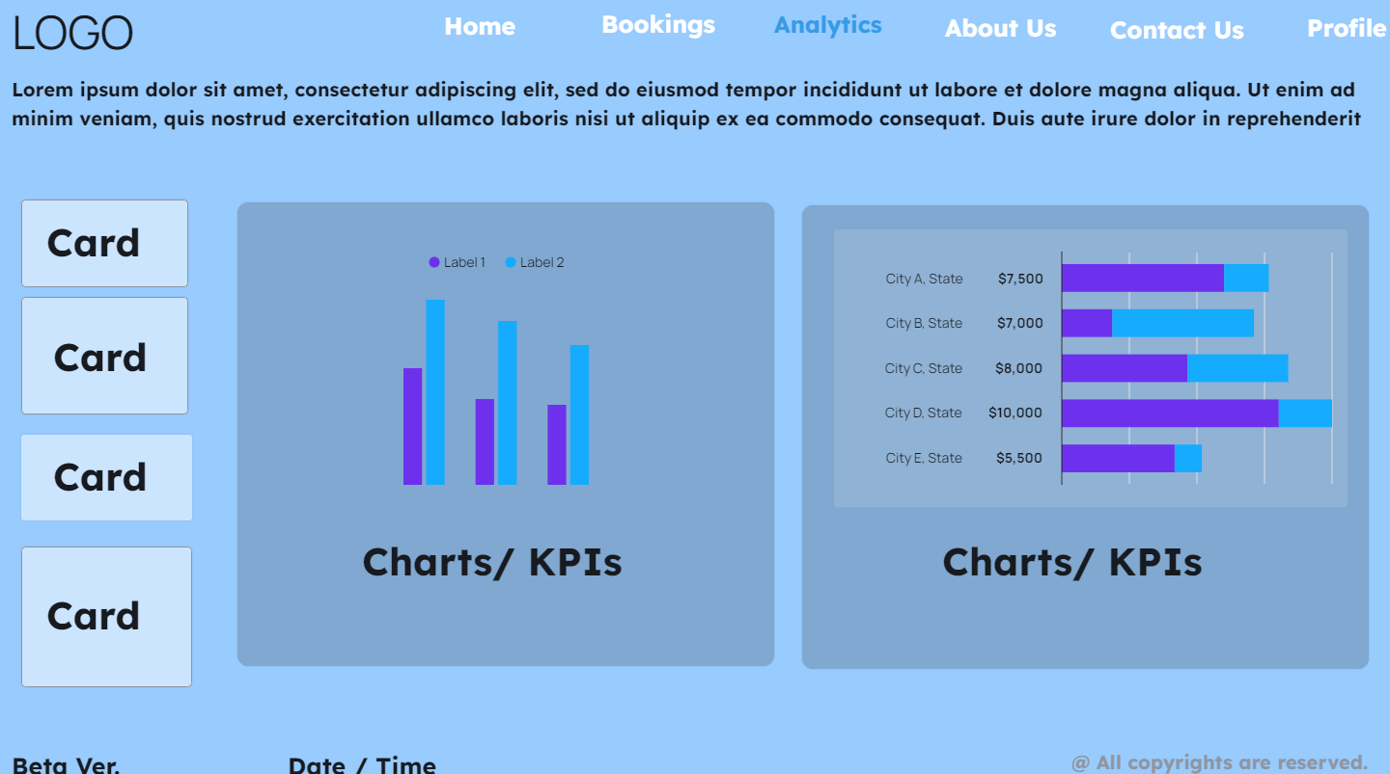

Figure 20: Prototype(Analytics Page)

#### 8.2.6.8) Contact Us Page

The below figure is an illustration of the prototype of the Contact Us page in the application.

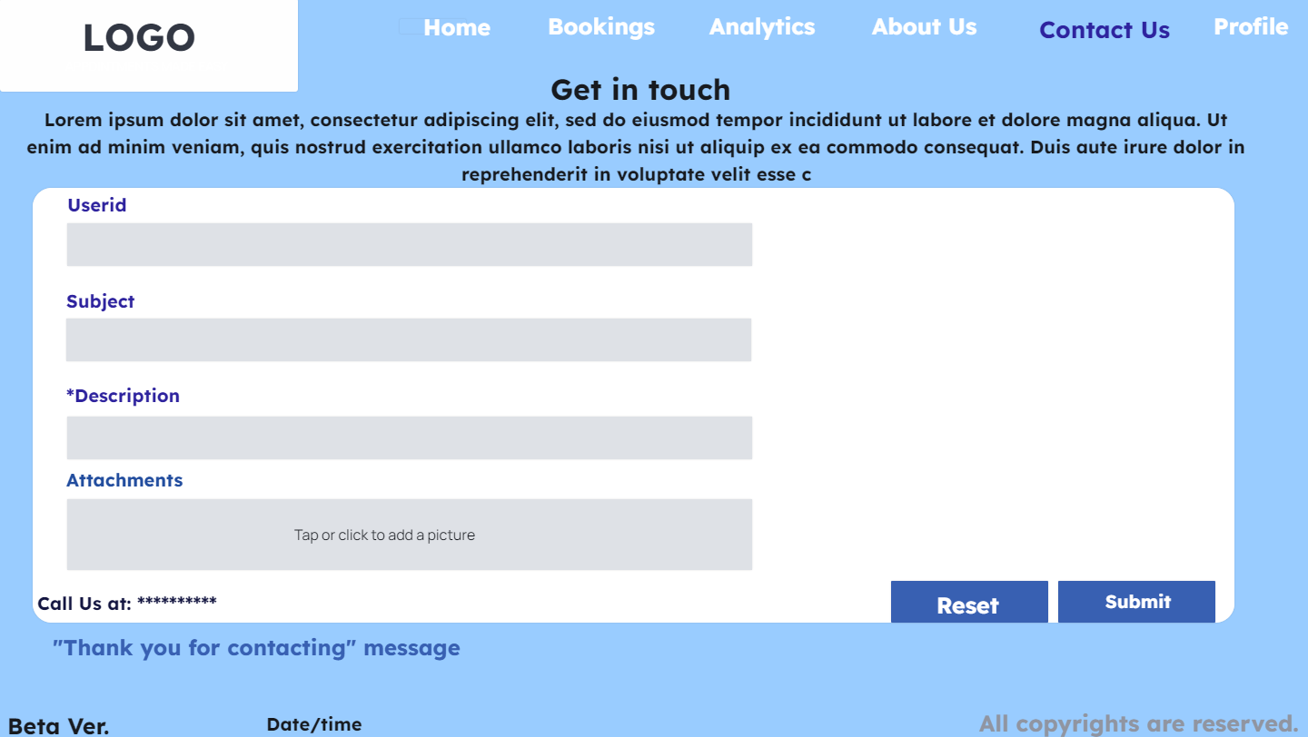

Figure 21: Prototype(Contact us Page)

#### 8.2.6.9) Profile Page

The below figure is an illustration of the prototype of the Profile page in the application.

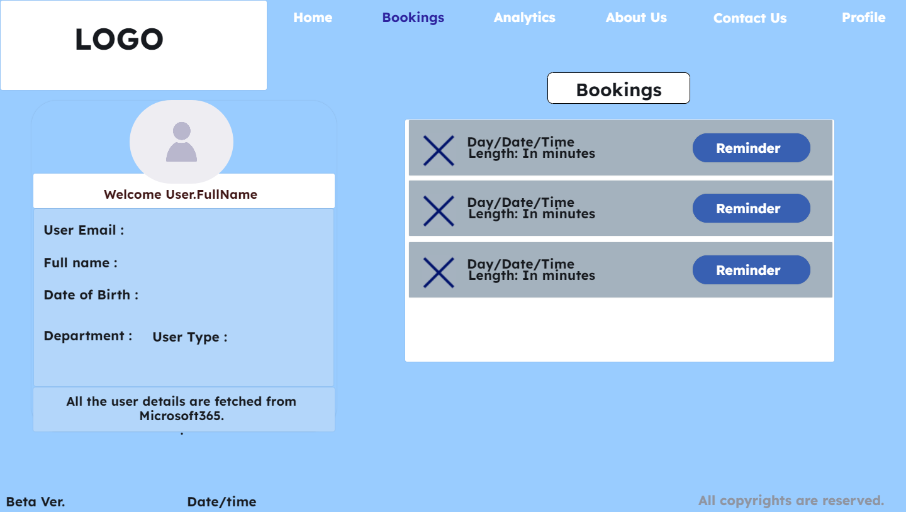

Figure 22: Prototype(Profile Page)

## 8.3) Database Design

Database design involves structuring and organizing data in a way that ensures efficient storage, retrieval, and management within the Croydon GP application, supporting its functionality and scalability.

### 8.3.1) Normalization

Normalization is a crucial process in database design that aims to minimize redundancy and dependency, ensuring data integrity and efficiency (Morris,S., 2022). By organizing data into separate tables and applying normalization rules, such as eliminating repeating groups and ensuring each table serves a single purpose, the Croydon GP application's database achieves a more streamlined and manageable structure, facilitating effective data storage and retrieval.

**0** **Normal Form 1st Normal Form 2nd Normal Form 3rd Normal Form**

User ID

Username

Password

Full Name

Email Address

Appointment Date

Timeslot

Reserved

Title

Slot Length

Feedback Date

Feedback Type

Feedback Category

Feedback Message

Rating

Contact Preference

Contact Subject

Contact Description

Contact Attachments

User ID

Username

Password

Full Name

Email Address

Appointment ID

Timeslot

Reserved

Title

Slot Length

Booked By

Symptoms

Feedback ID

User ID

Feedback Date

Feedback Type

Feedback Category

Feedback Message

Rating

Contact Preference

Contact ID

User ID

Subject

Description

Attachments

User ID

Username

Password

Full Name

Email Address

Appointment ID

Timeslot

Reserved

Title

Slot Length

Booked By

Symptoms

Feedback ID

Feedback Date

Feedback Type

Feedback Category

Feedback Message

Rating

Contact Preference

Contact ID

Contact Subject

Contact Description

Contact Attachments

User ID **(PK)**

Username

Password

Full Name

Email Address

Appointment ID **(PK)**

Timeslot

Reserved

Title

Slot Length

Booked By **(FK)**

Symptoms

Feedback ID **(PK)**

User ID **(FK)**

Feedback Date

Feedback Type

Feedback Category

Feedback Message

Rating

Contact Preference

Contact ID **(PK)**

User ID **(FK)**

Subject

Description

Attachments

### 8.3.2) Entity Relationship Diagram (ERD)

In SQL, the Entity-Relationship Diagram (ERD) serves as a visual representation of the database schema, illustrating the relationships between different entities and their attributes (Biscobing, J., 2019). By carefully designing the ERD for the Croydon GP application, a cohesive schema has been created, facilitating efficient data organization and retrieval. This schema helps ensure data integrity and consistency, allowing for smooth interaction between different components of the application and providing a solid foundation for future development and expansion.

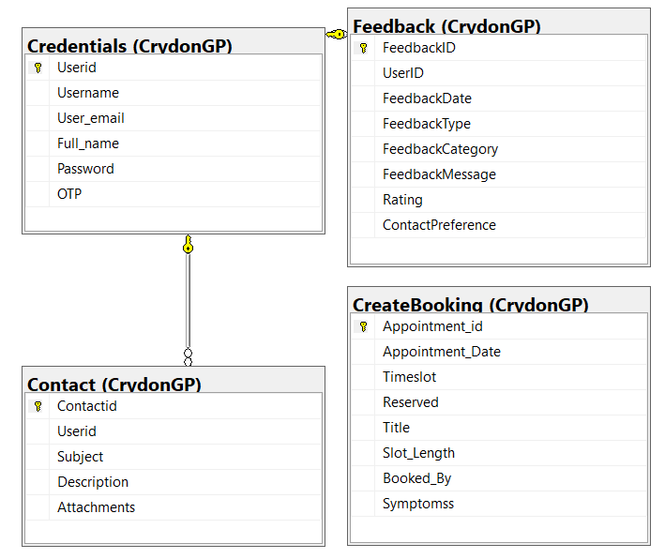

Figure 23: ERD

### 8.3.3) Data Dictionary

The following table describes the fields and attributes used in the Microsoft SQL Server for the application in brief.

**Credentials Table:**

|  |  |  |  |  |  |
| --- | --- | --- | --- | --- | --- |
| Field Name | Data Type | Constraint | Description | Example | Allow Nulls |
| Userid | int | Primary Key | This is user’s unique id | 1 | NO |
| Username | nvarchar(50) | N/A | Username for users | Md035@tees.uk | NO |
| User_email | nvarchar(50) | N/A | User email, fetched from the account | B1393756@live.tees.ac.uk | NO |
| Full_name | varchar(50) | N/A | User’s full name | MD Monajir Hussain | NO |
| Password | nvarchar(50) | N/A | User’s 8 digit password that contains at least a number and a special character | ******** | NO |
| OTP | Char(10) | N/A | Automatically generated random 6 digit number between (100000, 999999) | 140452 | YES |

Table 7: Credential Table

**CreateBooking Table:**

|  |  |  |  |  |  |
| --- | --- | --- | --- | --- | --- |
| Field Name | Data Type | Constraint | Description | Example | Allow Nulls |
| Appointment_id | int | Primary Key | This is appointment’s unique id | 1 | NO |
| Appointment_Date | date | N/A | Date of appointment | 2024-03-08 | YES |
| Timeslot | datetime | N/A | Start date and time of an appointment | 2024-03-08 09:00:00.000 | YES |
| Reserved | bit | N/A | This holds binary value i.e, true or false | 1 | YES |
| Title | nvarchar(50) | N/A | Title of the appointments | Ev1 | NO |
| Slot_Length | int | N/A | Slot length of appointment | 30 | YES |
| Booked_By | nvarchar(50) | N/A | Name of appointment holder | Monajir Hussain | YES |
| Symptomss | nvarchar(50) | N/A | Symptoms name/description | Dizzy | YES |

Table 8: Create Booking Table

**Contact Table:**

|  |  |  |  |  |  |
| --- | --- | --- | --- | --- | --- |
| Field Name | Data Type | Constraint | Description | Example | Allow Nulls |
| Contactid | int | Primary Key | This is contact’s unique id | 3 | NO |
| Userid | int | Foreign Key | This is user’s unique id | 5 | YES |
| Subject | ntext | N/A | Subject of the form | Loading time | YES |
| Description | nvarchar(MAX) | N/A | Description of the issue | The app is running slow | NO |
| Attachments | image | N/A | Any supporting documents/files | Imagexyz.png | YES |

Table 9: Contact Table

**Feedback Table:**

|  |  |  |  |  |  |
| --- | --- | --- | --- | --- | --- |
| Field Name | Data Type | Constraint | Description | Example | Allow Nulls |
| FeedbackID | int | Primary Key | This is feedback’s unique id | 5 | NO |
| UserID | int | Foreign Key | This is user’s unique id | 11 | YES |
| FeedbackDate | date | N/A | Date of feedback | 2024-03-19 | YES |
| FeedbackType | nvarchar(50) | N/A | Type of feedback from dropdown options | Compliment | YES |
| FeedbackCategory | nvarchar(50) | N/A | Category of feedback from dropdown options | Technical Issue | YES |
| FeedbackMessage | nvarchar(MAX) | N/A | Description of feedback | The UI looks amazing! | YES |
| Rating | int | N/A | Rating on the scale of 0-5 | 5 | YES |
| ContactPreferences | nvarchar(50) | N/A | Choices of being contacted | Email | YES |

Table 10: Feedback Table

# 9) Implementation

## 9.1) Database Implementation

Implementing the database is a crucial step before proceeding with the front-end development of the Croydon GP application. This phase involves setting up the database schema, creating tables to store relevant data, establishing relationships between these tables to maintain data integrity, and populating the tables with test data for validation. By completing this step first, the development team gains a clear understanding of how data will be structured and organized within the application. This allows for a more efficient implementation of the front-end interface, ensuring that data is displayed accurately and efficiently to the end-users.

### 9.1.1) Database Overview

For the backend, Microsoft SQL Server Management Studio is used. The database used is provided by the university called ‘mssql-database.tees.ac.uk.’. The Server type is Database engine with a SQL Server Authentication.

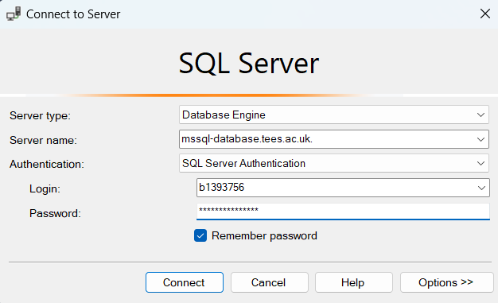

Image 9: SQL Server Longin

### 9.1.2) Database Schema Design

The database schema design process involves identifying the entities, attributes, and relationships that will be represented in the database. This typically begins with a thorough analysis of the application's requirements and user needs. In the case of the Croydon GP application, entities such as patients, appointments, and administrative staff may be identified. Attributes for each entity are determined based on the information that needs to be stored, such as patient demographics, appointment details, and provider information. Relationships between entities are established to reflect the connections between different types of data, such as the relationship between patients and their appointments, or between appointments and healthcare providers (Watt, 2014).

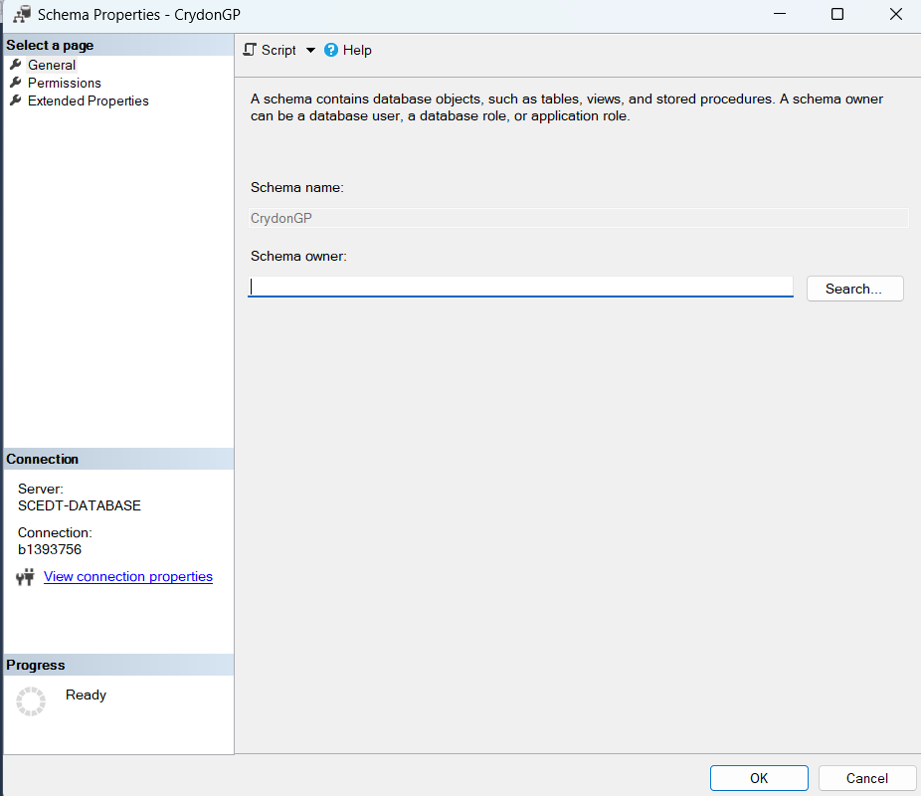

Image 10: Schema

### 9.1.3) Tables

The schema CrydonGP has four different tables. All of which serves a vital role in supporting the application. The brief description of each table is as follows:

1. CrydonGP.Credentials

* The Credentials table stores login details for users accessing the application. It typically includes columns such as username, email, password, and possibly additional fields for authentication purposes.
* This table plays a vital role in ensuring secure access to the application, as it verifies user identities during the login process.
* The use of encryption techniques for storing passwords and implementing robust authentication mechanisms helps enhance the security of user credentials.

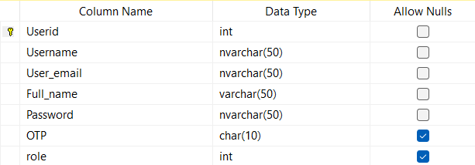 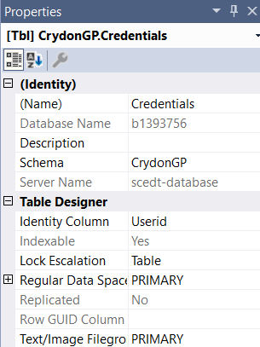

Image 11: Credentials Table Design Image 12: Table Properties(image 11)

1. CrydonGP.CreateBooking

* The CreateBooking table manages appointment timeslots and booking statuses within the application. It contains information about available timeslots, booked appointments, and related details.
* Key columns in this table includes Appintment_D, date and time of the appointment, status (e.g., booked, available), UserID (if applicable), and any additional attributes relevant to appointment management.
* This table is essential for facilitating the booking process, enabling users to schedule appointments, view available slots, and manage their bookings effectively.

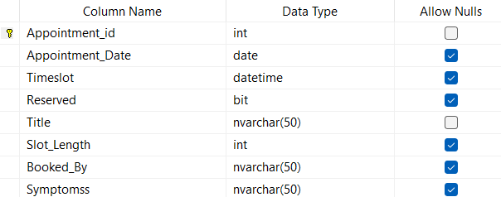 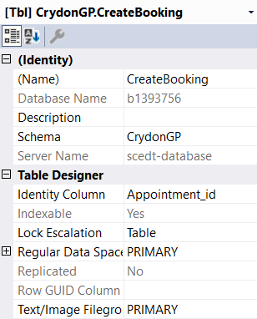

Image 13: CreateBooking Table Design Image 14: Table Properties(image 13)

1. CrydonGP.Contact

* The Contact table stores contact details provided by users, such as email addresses, phone numbers, and other relevant information.
* It serves as a means of communication between the application and its users, allowing the app to send notifications, updates, or other important messages to customers.
* By maintaining accurate contact information, the application can ensure effective communication with users, improving user engagement and customer satisfaction.

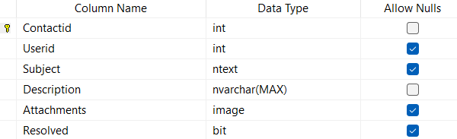 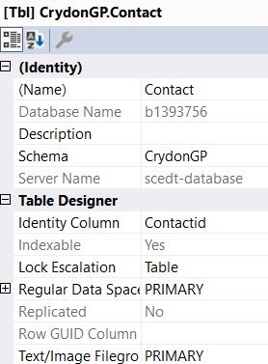

Image 15: Contact Table Design Image 16: Table Properties(image 15)

1. CrydonGP.Feedback

* The Feedback table collects feedback provided by users regarding their experience with the application. It captures comments, suggestions, ratings, or any other feedback submitted by users.
* Feedback data is valuable for assessing user satisfaction, identifying areas for improvement, and making informed decisions to enhance the application's features and functionality.
* Analysing feedback trends over time can help prioritize development efforts and address common user concerns, ultimately leading to a better user experience.

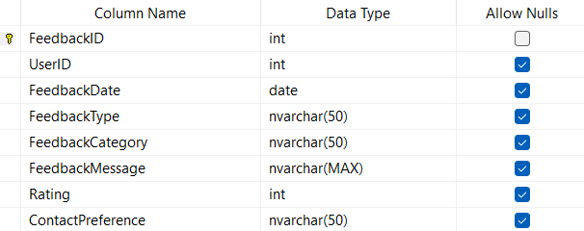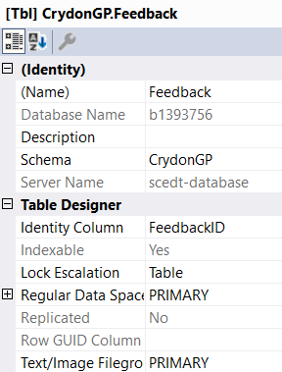

Image 17: Feedback Table Design Image 18: Table Properties(Image 17)

Overall, each of these tables plays a crucial role in supporting the ecosystem of the CrydonGP application, contributing to its functionality, security, user engagement, and continuous improvement. Proper design, management, and utilization of these tables are essential for the success of the application and the satisfaction of its users.

### 9.1.4) Test Data Showcase

This section presents curated screenshots of test data within the Croydon application. Users can preview various data types, including user credentials, booking details, contact information, and feedback submissions. These screenshots demonstrate the application's functionality and interface, providing insights into the user experience and data-driven features.

Please note that the showcased data is simulated for demonstration purposes only and may not reflect real user information or current application data. These screenshots familiarizes user with Croydon’s capabilities and interface design.

Credentials

/****** Script for SelectTopNRows command from SSMS ******/

SELECT TOP (10) [Userid]

,[Username]

,[User_email]

,[Full_name]

,[Password]

,[OTP],

,[role]

FROM [b1393756].[CrydonGP].[Credentials]

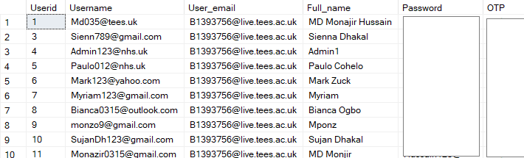

Image 19: Credentials Test Data

CreateBooking

/****** Script for SelectTopNRows command from SSMS ******/

SELECT TOP (10) [Appointment_id]

,[Appointment_Date]

,[Timeslot]

,[Reserved]

,[Title]

,[Slot_Length]

,[Booked_By]

,[Symptomss]

FROM [b1393756].[CrydonGP].[CreateBooking]

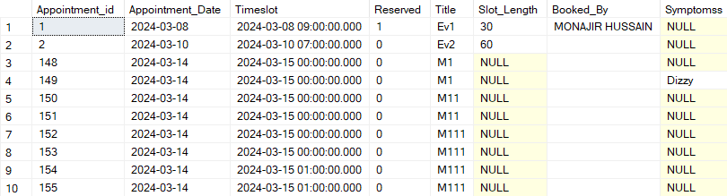

Image 20: CreateBooking Test Data

Contact

/****** Script for SelectTopNRows command from SSMS ******/

SELECT TOP (10) [Contactid]

,[Userid]

,[Subject]

,[Description]

,[Attachments]

,[Resolved]

FROM [b1393756].[CrydonGP].[Contact]

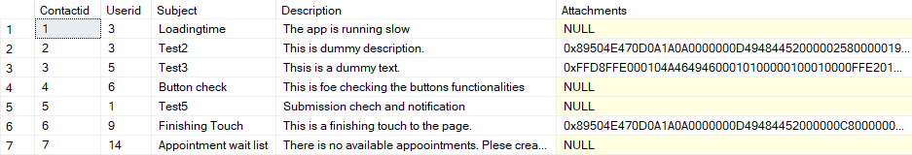

Image 21: Contact Test Data

Feedback

/****** Script for SelectTopNRows command from SSMS ******/

SELECT TOP (10) [FeedbackID]

,[UserID]

,[FeedbackDate]

,[FeedbackType]

,[FeedbackCategory]

,[FeedbackMessage]

,[Rating]

,[ContactPreference]

FROM [b1393756].[CrydonGP].[Feedback]

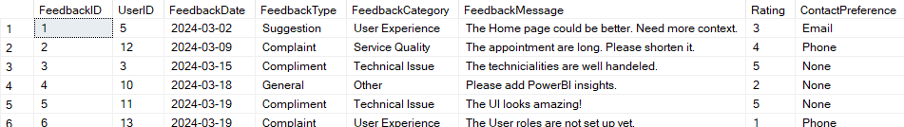

Image 22: Feedback Test Data

## 9.2) PowerApps Implementation

In this project, PowerApps plays a crucial role in translating the design concepts and functional requirements into interactive and user-friendly interfaces. It serves as the bridge between the user and the underlying data and functionalities of the application. By utilizing PowerApps, one can rapidly prototype, iterate, and deploy user interfaces tailored to the specific needs of the project (CodeCreator, 2023).

### 9.2.1) Integration with Data/Backend

PowerApps integrates seamlessly with various backend data sources, enabling bidirectional data exchange and real-time updates. To connect PowerApps to the backend database (e.g., SQL Server), the app uses connectors and data gateways provided by Microsoft (Capdevila, no date). The integration process involves:

* Establishing Connection: Configure the connection settings to establish communication between PowerApps and the backend data source.
* Data Binding: Define data connections and bind PowerApps controls to the corresponding data fields from the backend.
* Querying and Filtering: Retrieve, filter, and manipulate data from the backend using PowerApps formulas and functions.
* Data Validation: Implement data validation rules to ensure data integrity and consistency between PowerApps and the backend database.

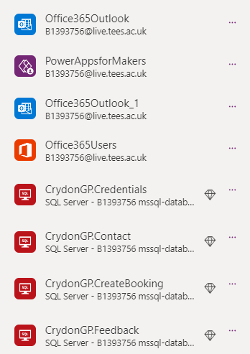In this project, Croydon GP has established connections with various tools to enhance functionality and user experience. With 8 connections in total, spanning across 4 different tools, the app ensures seamless data flow and communication.

Image 23: Data Connection

SQL serves as the backbone of the backend, facilitating the storage and retrieval of information critical to the app's operation. Through SQL, Croydon GP patches data, ensuring that users have access to the latest and most relevant information within the app.

Office365Outlook is utilized for sending emails and one-time passwords (OTPs) to users, enhancing security and communication capabilities. By leveraging Office365Outlook, Croydon GP ensures that users receive timely notifications and updates related to their appointments and account activities.

Office365Users is another essential tool integrated into the backend, enabling Croydon GP to fetch user information from the app environment. This integration streamlines the user authentication process and ensures personalized user experiences based on individual profiles and preferences.

Lastly, PowerAppsForMakers is employed to display essential app information, such as the app version and other relevant details. This integration provides transparency and clarity to users, helping them stay informed about the app's features and updates.

Overall, these backend integrations enhance the functionality, security, and usability of the Croydon GP app, ensuring a seamless and efficient user experience for all stakeholders.

### 9.2.2) Registration

The registration page for Croydon GP is designed to be simple and user-friendly, prioritizing ease of use and data security. With a clean layout and minimal color content, the page focuses on essential fields required for registration.

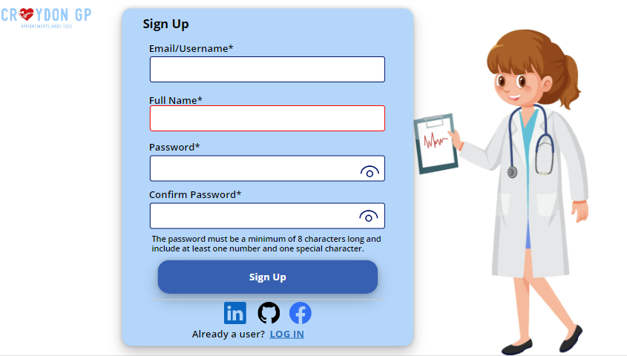

Image 24: Signup Page

Users are prompted to enter their username/email, full name, password, and confirm password. Stringent requirements ensure password strength, with a minimum length of 8 characters and inclusion of at least one number and one special character. The confirm password field serves as an added security measure, ensuring accuracy in password entry.

Once all fields are correctly filled, users can proceed to sign up by clicking the designated button. However, if any required field is incomplete or the password criteria are not met, the sign-up button remains inactive, prompting users to review and correct their inputs.

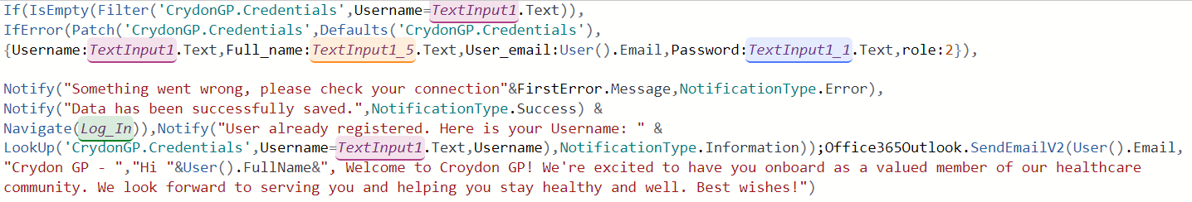

Image 25: Signup Button Code

Additionally, the registration page includes icons for registering with popular platforms such as Github, Linkedin, and Facebook. While these icons are displayed, they are kept inactive due to data privacy concerns, as Croydon GP is a local app and does not operate online. This decision ensures user data protection and confidentiality, prioritizing user trust and security in the registration process.

### 9.2.3) Login Page

The login page for Croydon GP offers a straightforward and secure method for registered users to access their accounts. Upon accessing the page, users are prompted to enter their email and password credentials. If both fields match the information stored in the database, users are successfully logged in to their accounts. However, if the provided credentials do not match, an error message is displayed, and users are unable to proceed with the login process until the correct information is entered.

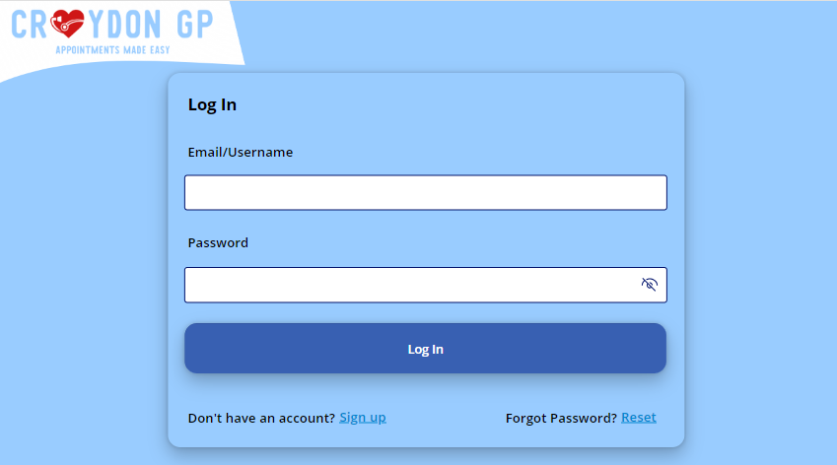

Image 26 : Login Page

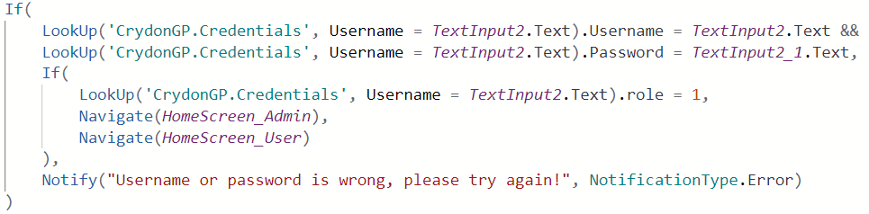

Image 27: Login Button Code

One notable feature of the application is its password reset functionality, which allows users to easily reset their passwords in the event of forgetting them. By clicking the "Forget Password" button on the login page, users initiate the password reset process. They receive a 6-digit random OTP (one-time password) via email, which serves as a security measure to verify their identity. After verifying their identity by entering the OTP and their User ID, users can set a new password for their account.

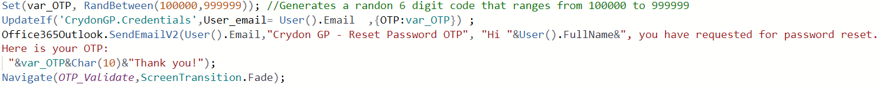

Image 28: Reset Button Code

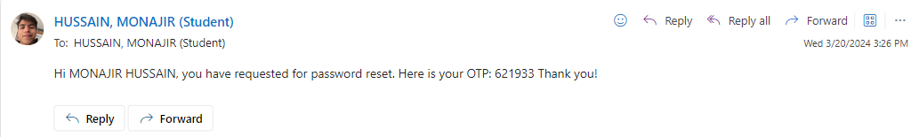

Image 29: OTP Email

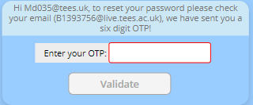 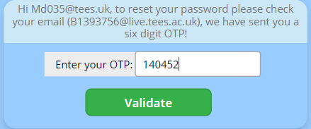

Image 30: OTP Validation

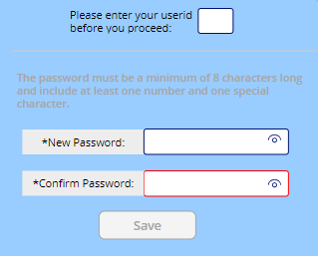

It is also important to note that User IDs are kept relatively short, typically consisting of 1 or 2 digits for simplicity and ease of use. However, in a public launch scenario, longer and more complex User IDs, akin to private keys, would be employed to enhance security measures.

Upon successful login, users are directed to their respective dashboard pages based on their roles, whether as a general user or an admin. Each role grants access to different pages and controls within the application, ensuring a tailored and secure experience for every user.

### 9.2.4) Header and Footer

The header and footer elements of the Croydon GP application provide users with consistent navigation and important information across all pages.

At the top left corner of each page, users will find the Croydon GP logo, ensuring brand consistency and easy recognition. Adjacent to the logo is the user-friendly navigation menu, which varies depending on whether the user is an admin or a general user. This navigation menu allows users to seamlessly move between different sections of the application, providing a smooth user experience.



Image16 : Navigation Tab

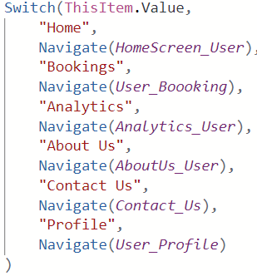 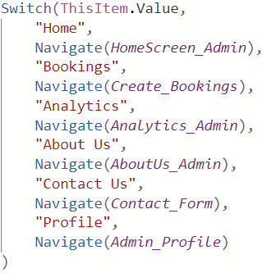

Image 31: User Navigations Image 32: Admin Navigations

Furthermore, the layout of each page within the application is carefully crafted to offer a unique and visually appealing experience. Whether users are accessing appointment scheduling, viewing analytics, or exploring other features, each page is designed with its own distinct layout to optimize usability and aesthetics.

Moving to the bottom of the pages, users will encounter three labels in the footer section. The first label contains simple copyright text, ensuring that proper ownership and usage rights are acknowledged. The second label displays the current time and date, providing users with real-time information for reference. Lastly, the third label indicates the version of the application, which automatically updates whenever a new version is published. This feature allows users to easily identify which version of the application they are using and stay informed about any updates or improvements.

### 9.2.5) Home Page

The home page of the Croydon GP application adopts a minimalist and user-centric approach, prioritizing ease of booking appointments for users. The layout is intentionally kept simple to ensure clarity and intuitive navigation.

At the center of the home page, users will find a prominent "Book Now" button, inviting them to quickly access the booking functionality of the application. This strategic placement emphasizes the primary purpose of the app, which is to facilitate seamless booking and management of GP appointments.

To add a touch of visual appeal and personality to the page, a cartoon image of a doctor is featured. This lighthearted visual element not only enhances the aesthetic appeal of the home page but also contributes to a welcoming and friendly user experience.

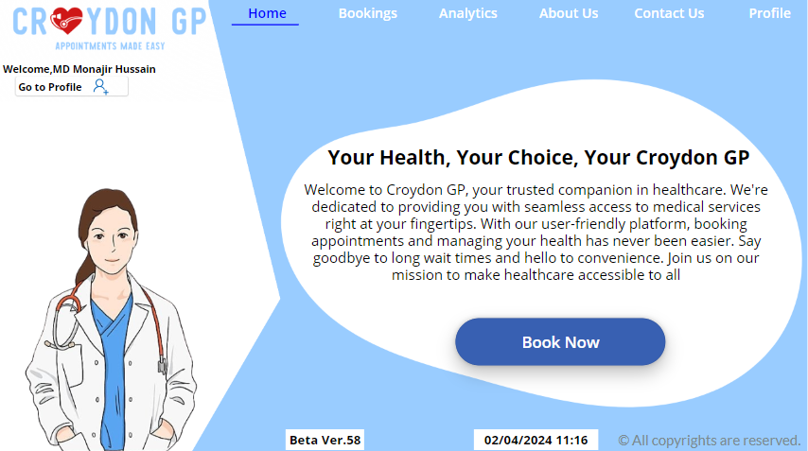

Image 33: Home Page

Overall, the home page of the Croydon GP application strikes a balance between simplicity and functionality, providing users with easy access to the core features of the app while maintaining an engaging and user-friendly interface.

### 9.2.6) Bookings Page

#### 9.2.6.1) Administrative Bookings Page

The Bookings page, exclusively accessible to administrators, holds paramount importance within the Croydon GP application. Serving as a pivotal hub for appointment management, this page empowers administrators to create and oversee various appointment slots, facilitating seamless scheduling for users.

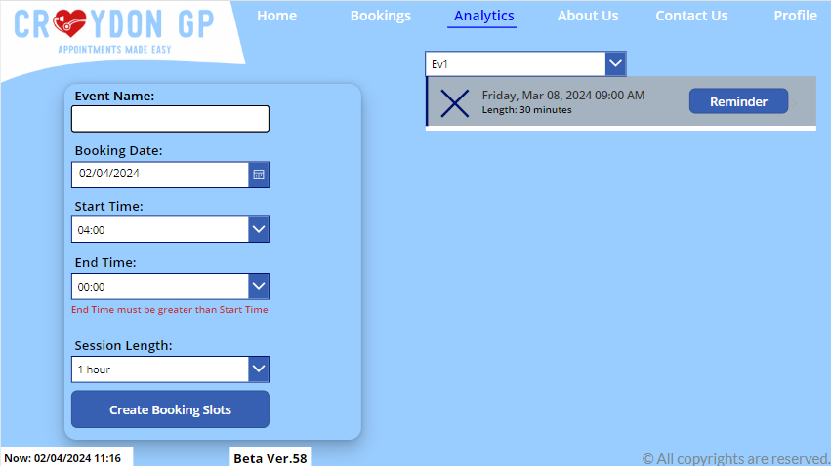

Image 34: Admin Bookings Page

At the heart of the Bookings page lies a custom form, meticulously crafted to streamline the process of creating appointment slots. The form presents administrators with essential fields such as 'Event Name,' enabling them to categorize appointments based on specific healthcare events, thus optimizing resource allocation and patient care, which in result will help in funding allocation that will keep the pace with the increasing demand (TheMedicalPortal, no date). Additionally, fields like 'Booking Date,' 'Start Time,' 'End Time,' and 'Session Length' equip administrators with the necessary parameters to define appointment slots efficiently.



Image 35: Time Code

The functionality of the 'Create Booking Slots' button, situated within the form, epitomizes the meticulous attention to detail invested in the development process. Despite encountering obstacles such as backend errors and spelling discrepancies, its successful implementation stands as a testament to the developer’s perseverance and commitment to delivering a robust solution. Upon selection, the button triggers a series of mathematical calculations, processing the manipulation and storage of data in the backend, thereby facilitating the seamless creation of appointment slots.

Complementing the form is a dynamic vertical gallery, providing administrators with an intuitive interface to manage appointments effectively. Equipped with a search bar, the gallery enables quick and precise filtering of appointments, enhancing administrators' productivity and workflow efficiency. Moreover, the inclusion of a 'Reminder' button underscores the app's user-centric design, aiming to offer users timely notifications ahead of their scheduled appointments. Despite encountering temporary data connection issues affecting the functionality of the Reminder button, ongoing efforts are underway to address and resolve this issue promptly.

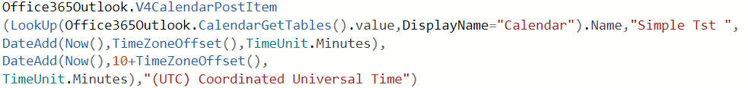

Image 36: Reminder Button Code

#### 9.2.6.2) User Bookings Page

The User Bookings page in the Croydon GP application offers users a streamlined interface to manage their appointments efficiently. Distinguished from the Admin Bookings page, users have access solely to the appointment gallery, where they can book and manage their scheduled appointments effortlessly.

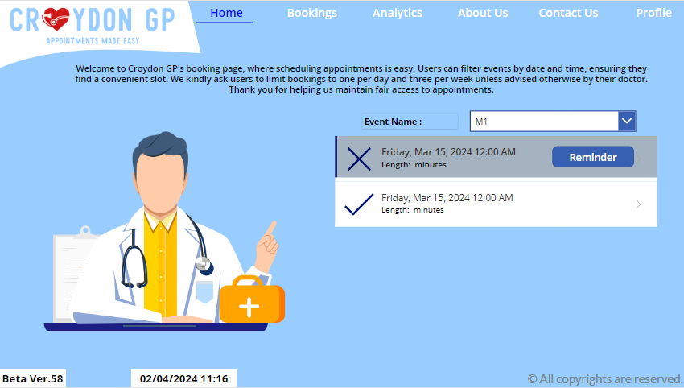

Image 37: User Bookings Page

At the forefront of the User Bookings page is a vibrant and engaging interface that aligns seamlessly with the app's user-friendly design ethos. Instead of the comprehensive form present on the Admin Bookings page, users are greeted with a captivating cartoon doctor's image, serving as a placeholder and preserving the app's thematic consistency. This thoughtful design element not only enhances the user experience but also adds a touch of personality to the booking process.

The appointment gallery provides users with a visual overview of their scheduled appointments, facilitating quick and intuitive management. Users can easily browse through their appointments, make new bookings, and cancel existing ones with just a few taps. Despite the absence of advanced administrative functionalities, the User Bookings page prioritizes simplicity and accessibility, ensuring that users can navigate the app effortlessly and efficiently.

By focusing on user-centric design principles and maintaining thematic coherence throughout the interface, the User Bookings page exemplifies the Croydon GP application's commitment to delivering an intuitive and engaging healthcare management solution for all users.

### 9.2.7) Analytics Page

The Analytics page in Croydon GP is like a map that helps people explore important health information. It's like looking at colourful pictures that tell stories about people's health. The page shows things like how many appointments were missed, which areas have the most patients, and what kinds of health problems are common. It's like having a big puzzle with all the pieces put together to see the whole picture of health in the community.

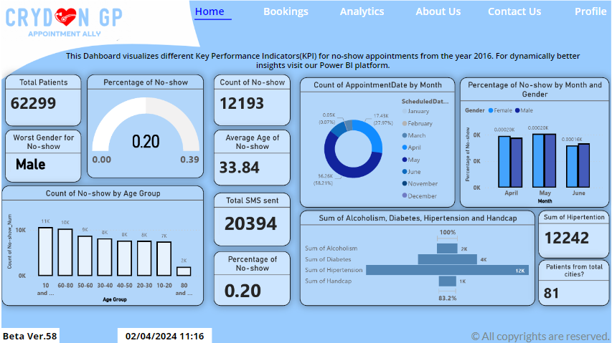

Image 38: Analytics Page

Power BI helped to take lots of data and turn it into easy-to-understand charts and graphs. These charts show trends and patterns in the data, like which days people miss appointments the most, or which age groups need the most help. Even though the page has lots of information, it's designed to be simple and easy to use. Users can't click on the graphs or change anything as the dashboard is not tiled into the Power Apps because of in-app purchase, but they can still see all the important details at a glance.

### 9.2.8) About Us Page

The About Us page of the Croydon GP application serves as a comprehensive hub of information, providing users with valuable insights into the app's mission, impact, and team members. The page is designed with a vertical overflow scroll layout, allowing for seamless navigation through an extensive array of content within a single page.

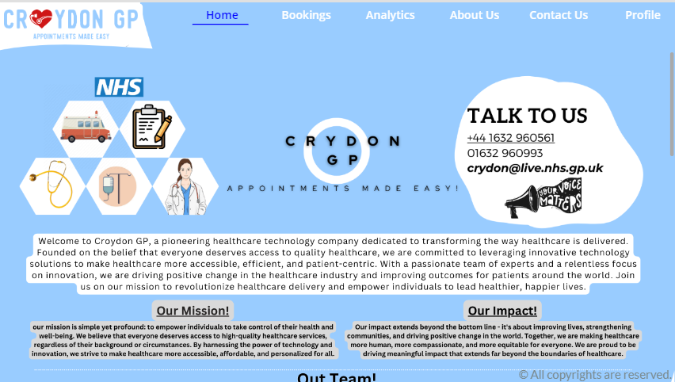

Image 39: About Us Page

At the forefront of the About Us page is a succinct overview of the app's theme, encapsulating its core values and objectives. This introductory section sets the tone for the rest of the page, offering users a glimpse into the app's overarching mission and purpose.

Additionally, the About Us page features essential contact details, ensuring that users can easily reach out for support or inquiries. This accessibility reinforces the app's commitment to fostering transparent communication and user engagement.

One of the key highlights of the About Us page is its emphasis on the app's mission and impact. Through compelling narratives and data-driven insights, users gain a deeper understanding of the app's significance in addressing healthcare challenges and improving patient outcomes.

Lastly, the About Us page culminates with a captivating Croydon GP video, offering users a visually engaging overview of the app's features and functionalities. Created using a combination of free short videos and an AI voiceover, this video serves as a dynamic showcase of the app's capabilities and value proposition.

### 9.2.9) Contact Us Page

#### 9.2.9.1) User Contact Us Page

The Contact Us page serves as a virtual conduit for users to engage with the administrative team behind Croydon GP. Here, users are provided with a structured form where they can furnish essential details such as their Userid, Subject, and the description of their message. Additionally, users have the option to append relevant images or files to their correspondence, facilitating a comprehensive exchange of information.

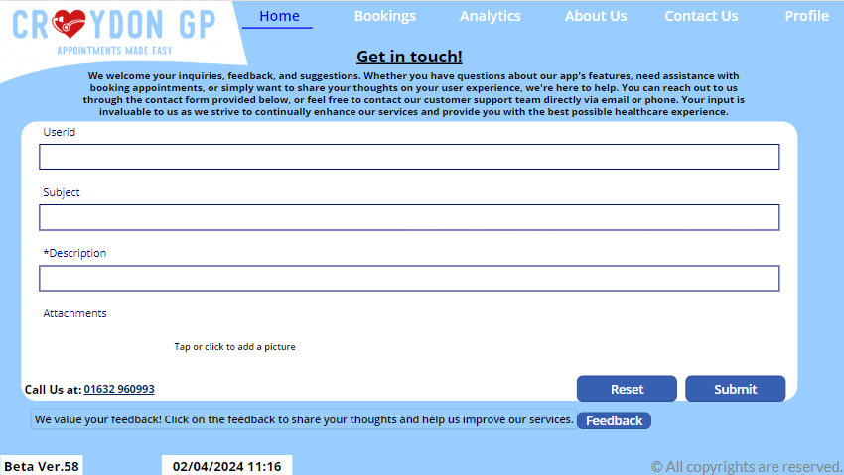

Image 40: Contact Us Page

Upon submission of the form, the user's message is swiftly dispatched to the admin's inbox, akin to the expedited delivery of a traditional letter. Subsequently, the administrative team diligently reviews each incoming message, prioritizing timely responses to address user inquiries or feedback. This streamlined communication channel underscores the commitment of Croydon GP to fostering user engagement and satisfaction.

#### 9.2.9.2) Admin Contact Us Page

The Admin Contact Us page mirrors the User Contact Us Page but offers tailored functionality suited to administrative tasks. Featuring a familiar layout, the page replaces the form with a dynamic gallery that presents incoming messages from users. Admins are empowered to efficiently manage user communications by reviewing messages directly within the gallery interface.

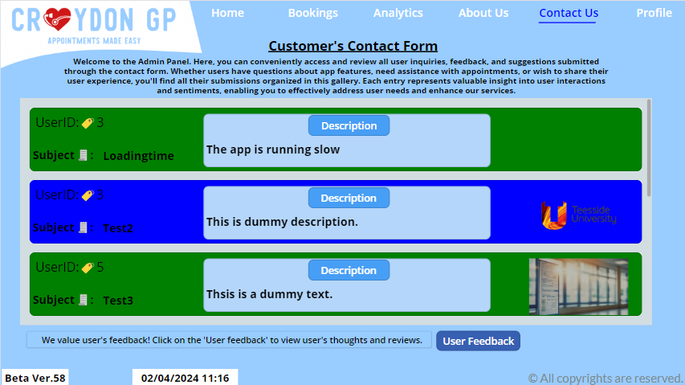

Image 41: Contact Form Page

To facilitate effective issue tracking and resolution, admins have the ability to designate message statuses as "Resolved" or "In Progress" directly within the backend system. Messages marked as resolved are visually distinguished with a green grid, signifying successful resolution, while messages in progress are denoted with a blue grid. This intuitive color-coding system enhances administrative oversight and ensures prompt attention to user inquiries or concerns.

### 9.2.10) Feedback Page

#### 9.2.10.1) User Feedback Page

The User Feedback page provides users with a platform to share their insights and suggestions, fostering a collaborative environment for app improvement. Through a simple form interface, users can express their opinions on various aspects of the application, highlighting areas that require enhancement or acknowledging functionalities that meet their expectations.

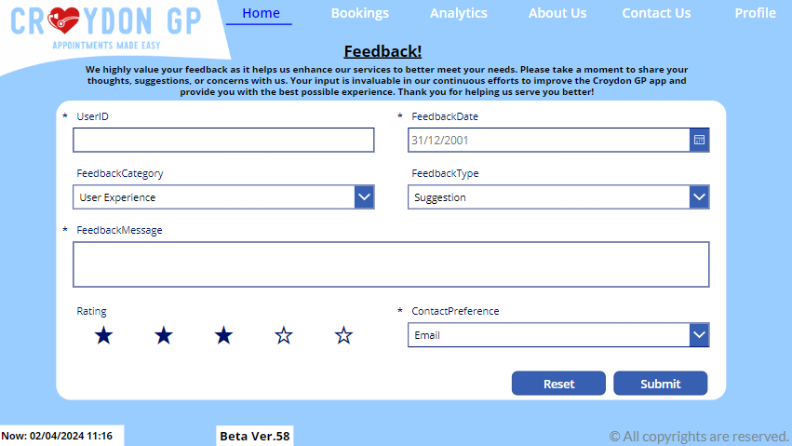

Image 42: User Feedback Page

This feedback mechanism serves as a valuable consultancy tool, offering direct input from users to guide the ongoing refinement and optimization of the app. By actively soliciting and considering user feedback, the app strives to continuously evolve in alignment with user needs and preferences, ultimately enhancing the overall user experience.

#### 9.2.10.2) Admin Feedback Page

The Admin Feedback page mirrors the layout and design of the User Feedback page, featuring a gallery format to display feedback submissions from users. However, instead of a form, the admin interface presents a comprehensive view of all feedback entries, allowing administrators to assess and respond to user comments effectively.

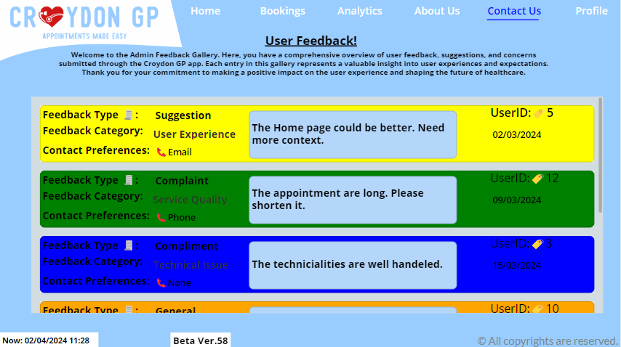

Image 43: Admin Feedback Page

Each feedback entry is accompanied by detailed fields outlining various aspects of the feedback, providing valuable insights to inform app improvements. To facilitate efficient review and prioritization, a color-coded system is implemented based on the feedback rating scale of 1 to 5. Using a Priority Colour Scheme (no date), feedback entries are colour-tagged to indicate their corresponding rating, with colours ranging from red to blue representing ratings from 1 to 5, respectively. This intuitive visual cue enables administrators to quickly identify and prioritize feedback based on its perceived importance and impact on app enhancements.

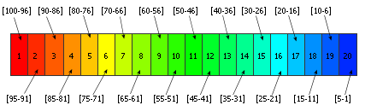

Image 44: Priority Colour Schema

### 9.2.11) Profile Page

The Profile page serves as a comprehensive hub for users to access and manage their personal information and appointment bookings seamlessly. Positioned on the left-hand side of the page is a profile grid presenting essential user details such as profile image, email, full name, date of birth (DOB), department, and user type. These details are dynamically fetched from the user's environment, leveraging the existing database infrastructure. For instance, within the university environment, user information is sourced directly from university records, ensuring real-time accuracy and eliminating the need for manual updates. Similarly, in an NHS environment, user profiles are automatically synchronized with the NHS database, reflecting any changes in department or user status across the system.

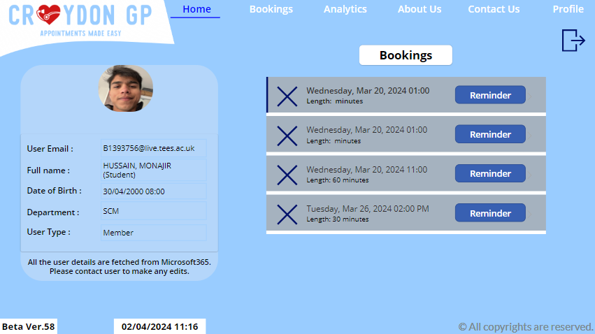

Image 45: Profile Page

On the right-hand side of the page, a gallery interface displays a comprehensive list of the user's appointment bookings. This intuitive layout streamlines navigation by providing users with quick access to their bookings without the need to navigate to separate booking pages repeatedly. Users can effortlessly manage their appointments directly from the profile page, allowing for convenient updates or modifications as needed. This integration of user profile information and appointment management features enhances user experience by centralizing key functionalities within a single, user-friendly interface.

## 9.3) Power BI

### 9.3.1) Dataset Overview

**Understanding Patient No-Shows: Insights from Medical Appointment Data**

In the context of the Croydon GP application, it is aimed to leverage the "Medical Appointment No Shows" dataset to gain valuable insights into patient attendance behaviours. The dataset is downloaded from Kaggle which has the data from May 2016 from Brazil, posted and updated by Jonihoppen (2016). By integrating this dataset into the Power BI analytics platform, the app seeks to unravel the underlying factors contributing to appointment no-shows and identify opportunities for intervention and improvement within healthcare system.

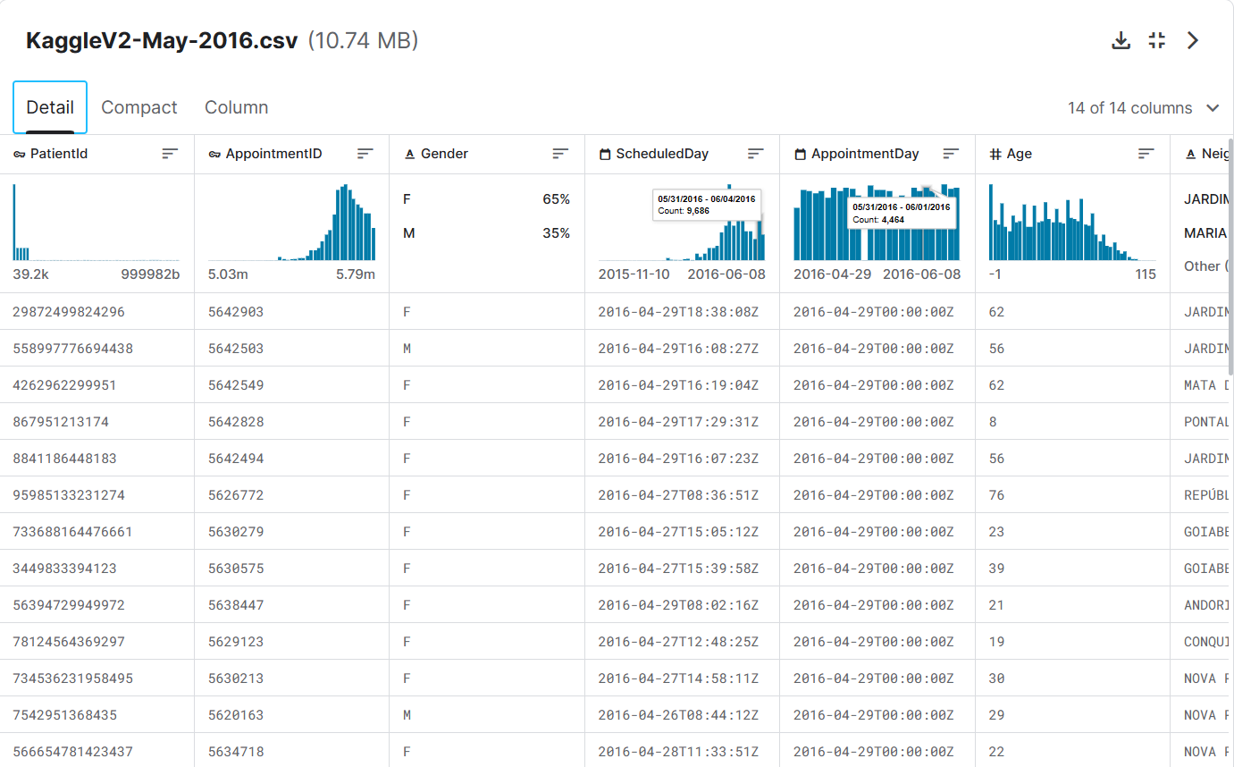

Image 46: KaggleV2-May-2016.csv

* Analysing Appointment Dynamics:

With over 110,000 medical appointments and 14 associated variables, this dataset provides a rich source of information for understanding patient behaviours and appointment outcomes. Through detailed analysis of patient demographics, appointment scheduling details, and health-related factors, it is aimed to uncover patterns and correlations that influence appointment attendance.

* Informing Decision-Making:

By harnessing the power of data analytics, Croydon GP can make informed decisions to optimize appointment scheduling processes, reduce no-show rates, and enhance overall patient engagement. Insights derived from the dataset would enable to tailor various approaches to appointment reminders, outreach strategies, and patient communication methods to better meet the needs of diverse patient population.

* Driving Continuous Improvement:

The utilization of this dataset underscores Croydon GP's commitment to data-driven decision-making and continuous improvement. By leveraging insights gleaned from this dataset, identifying areas of opportunity for enhancing service delivery, fostering patient satisfaction, and ultimately improving health outcomes within the community.

In summary, the integration of the "Medical Appointment No Shows" dataset into Power BI analytics platform represents a significant step forward in the quest to optimize appointment scheduling processes, reduce no-show rates, and enhance the overall patient experience within the Croydon GP ecosystem.

### 9.3.2) Data Pre-Processing

Before the dataset is set to be imported, it will go through a pre-processing for the purpose of cleaning by removing any duplicate or irrelevant entries, handle missing values, and ensure consistency in data formats.

**Overview of data cleaning:**

Duplicate entries are removed based on unique identifiers like PatientId or AppointmentID. Missing values are handled in columns such as Age, Gender, and Neighbourhood by imputation or removal. Scholarship column is deleted as this does not serve any insights for the desired dashboard. Ensuring consistency in date formats is considered.

Columns are split for individuality of data and for better insights. For instance, ScheduledDay Column which is in date/time format is split into two to get ScheduledDate and ScheduledTime columns in the date and time format respectively.

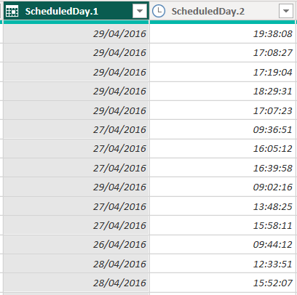 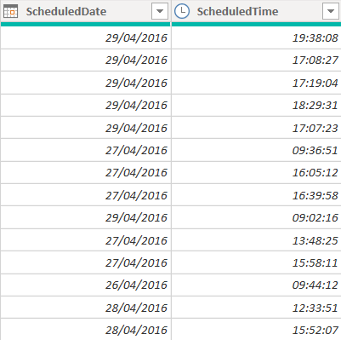

Likewise, AppointmentDay column is split into AppointmentDate and AppointmentTime columns in the date and time format respectively.

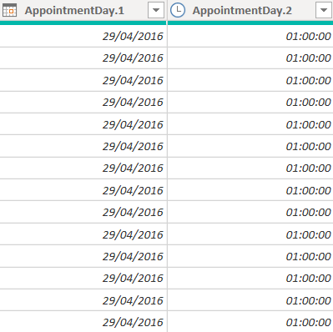 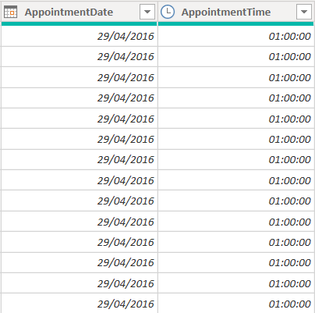

Image 47: Split Columns

No-show column is a Boolean data type, which can be more valuable in the visualization if modified. To get the Binary data, that is 1s and 0s, a new column will be added.

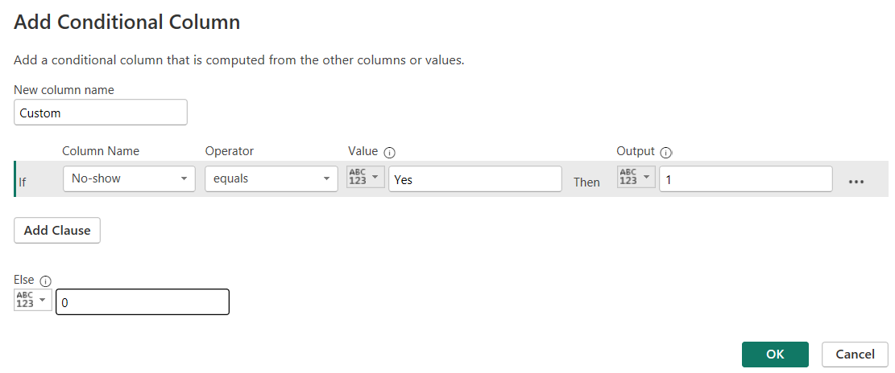

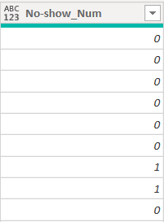Image 48 : Conditional Column

New column is resulted. The data type and renaming is done accordingly.

**Calculated Measures using DAX :**



This measure counts the total row of the dataset and gives a valuable entity for the visual representation.

Average age of No-show



Count of number of No-show



Count of Total of number of No-show



Worst Gender for No-show



**Calculated Columns – Bins/Groups**

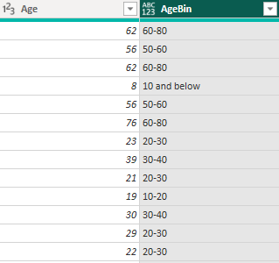

Bins are created and added the data type accordingly.

### 9.3.3) Data Modelling (Star schema)

In Power BI Implementation, data modelling using the star schema method is essential for structuring healthcare datasets efficiently. The star schema consists of a central fact table containing measures like appointment counts and patient attendance rates, surrounded by dimension tables providing context with attributes such as patient details, appointment information, and time. Relationships between tables enable cross-table analysis, while hierarchies organize data for easy drill-down and roll-up. This structured approach ensures accurate analysis and empowers users to derive valuable insights from healthcare data.

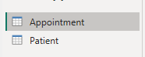Now the tables are duplicated and modelled then renamed.

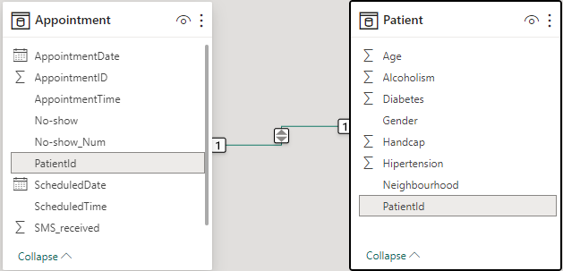

Image 49: Data Modelling

Here, dataset is modelled. PatientId is the primary key in Patient table and Foreign key in Appointment table.

### 9.3.4) Visualization

In the Power BI implementation, the dashboard has been meticulously designed to ensure user-friendliness and adherence to the Croydon GP theme. Carefully selected colors maintain consistency with the app's branding. Key information is presented through data cards, offering a snapshot of essential metrics. Additionally, various graphs, charts, and indicators provide in-depth insights into different aspects of healthcare data. Users can interact with the dashboard to explore data based on age group, gender, date, diseases, and more, enhancing the app's overall insightfulness and usability.

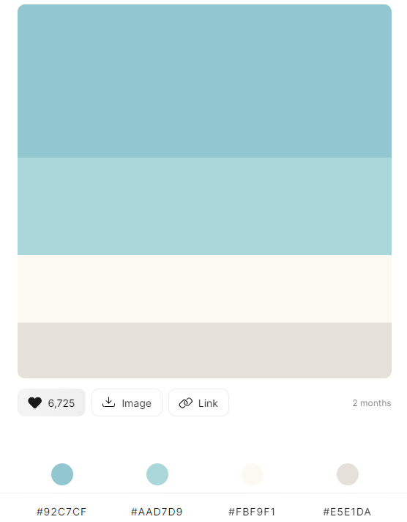

Image 50: Power BI Colour Palette

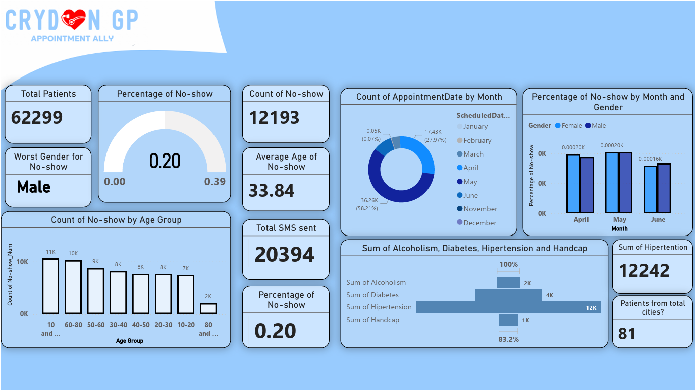

Image 51: Power Bi Dashboard

**KPIs Overview**

1. Data Cards

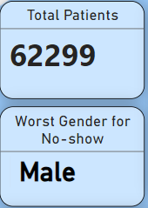 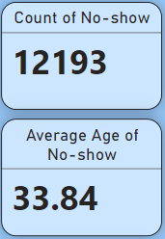 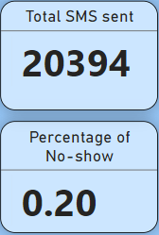 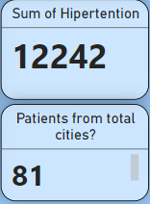

Image 52: Data Cards

These data cards are simple yet give quick and important overview of the dataset that has thousands of data which is not realistic for people to analyse in seconds. These data cards are created by performing different DAX measure, calculated columns and other operations while cleaning the dataset.

1. 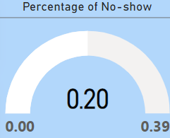Gauge Indicator

This graph shows the total percentage of no-show and targeted number of no-show. This gives better insights into the goals planning and achievements.

Image 53: Gauge

1. Stacked Column Chart

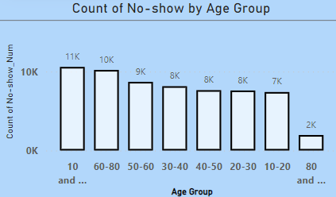

Image 54: Stacked Column Chart

This chart shows the total count of no-show based on age group. The age groups are divided with 10 years age gap. This help in the study of various risks of diseases based on age group.

1. Donut Chart

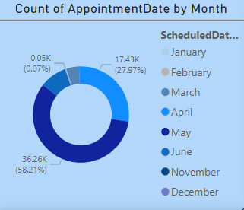

Image 55: Donut Chart

The chart filters the no-show appointments by distinct months so that it can be identified what months had the highest number of missed appointments and actions could be taken accordingly.

1. Clustered Column Chart

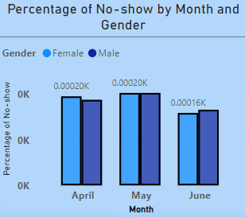

Image 56: Clustered Column Chart

This chart shows the total percentage of missed appointments by months based on gender. Here the main months for missed appointments are April, May and June. So using this chart, total percentage of no-show for male and/or female be identified.

1. Funnel

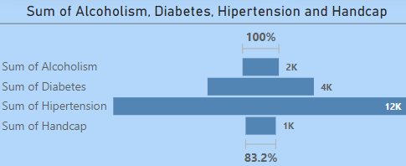

Image 57: Funnel

This chart shows total number of patients categorized according to main chronic like Diabetes, Handicap, Alcoholism and Hypertension. This can help in allocating the fun and resources in a planned manner.

## 9.4) Technical Challenges and Issues

During the development process of the app, numerous technical challenges were encountered, some of which were successfully resolved while others remain ongoing. One such challenge involved the reset password functionality, where an issue arose due to the email OTP being the same for all users fetched from the developer's platform, resulting in unintended password changes for multiple users. After seeking assistance from a one of the LinkedIn experts, the issue was traced back to a data type error in the formula.

 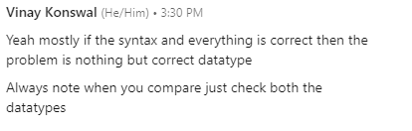

Image 58: Reset Button Issue

Another significant challenge was encountered with the create booking button, which failed to function correctly and threw a Patch function error. Despite extensive efforts to resolve the issue by searching online resources and seeking guidance from peers, the problem persisted until a tutor identified a simple spelling error in the formula. However, the delay in identifying the issue led to subsequent errors in multiple buttons and labels within the application.

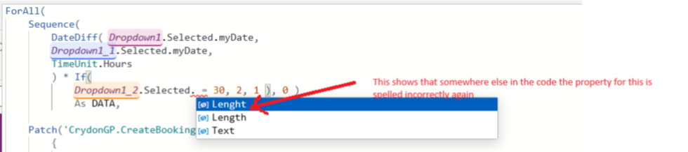

Image 59: Create Bookings Button Issue

Additionally, the embedding of the Power BI report into the app posed a challenge as it could only be embedded one page at a time with limited interactive functionality, hindering navigation and filter options. Further research revealed that only premium Power BI accounts could embed a full report with full interactivity, prompting the use of a dashboard image in the application instead.

Last but not least, the reminder button functionality, designed to remind users of their appointments, remained unresolved due to issues with the emailing connectors. Despite thorough background research, the problem persists, requiring further investigation and troubleshooting. Overall, while many technical challenges were overcome during the development process, some complexities remain unresolved, highlighting the iterative nature of app development and the importance of ongoing refinement and improvement.

# 10) Testing

## 10.1) Introduction

The purpose of this test plan is to outline the testing approach and strategies for the Croydon GP web application. The testing will encompass various aspects including functionality, usability, security, and performance to ensure the quality and reliability of the application.

## 10.2) Objectives

* To verify the functionality of key features such as user registration, appointment booking, and feedback submission.
* To evaluate the usability and user experience of the application across different devices and browsers.
* To assess the security measures implemented to protect user data and prevent unauthorized access.
* To measure the performance of the application in terms of speed, responsiveness, and scalability.

## 10.3) Scope

The testing will cover the following aspects of the Croydon GP web application:

* User registration and login
* Appointment booking and management
* Contact and feedback forms
* Security features including data encryption and access controls
* Performance under normal and peak load conditions

## 10.4) Test Environment

* Operating System: Windows
* Browser: Chrome
* Devices: Desktop, Laptop
* Tools: Not Applicable

## 10.5) Test Plan

|  |  |  |  |  |  |  |
| --- | --- | --- | --- | --- | --- | --- |
| Test ID | Test Case | Pre-Conditions | Test Procedure | Test Data | Expected Result | Actual Result |
| 1. | User Registration | User is not logged in and is on the Sign Up page. | 1. . Click on the "Sign Up" button on the login page.  2. Fill out the required fields in the registration form.  3. Click on the "Sign Up" button.  4. Verify registration success. | Userid: 23, Username: [Barry157@gmail.com](mailto:Barry157@gmail.com) , Full_name: Barry Allen, Password:Allen123@ | User should be able to register an account successfully. | PASS |
| 2. | User Login | User has already registered an account. | 1. Navigate to the login page.  2. Enter registered email and password.  3. Click on the "Login" button.  4. Verify login success. | Email/Username: [Barry157@gmail.com](mailto:Barry157@gmail.com)  Password: Allen123@ | User should be able to log in successfully. | PASS |
| 3. | Sign In with Social accounts (Github, LinkedIn, and Facebook) | User is on the login page and chooses to sign in with socials | 1. Click on the respective sign In with social accounts. 2. Enter respective credentials if prompted. 3. Click on the "Authorize" button. 4. Verify if the user is redirected to the app dashboard or logged in successfully. | Github/LinkedIn/Facebook credentials (as applicable) | User should be able to sign in using their respective account. | FAIL |
| 4.1 | Reset Password without UserId | User is logged in and wishes to reset their password. | 1. Click on the "Reset Password" button, to receive OTP.  4. Enter OTP.  5. Enter new password.  6. Click on the "Save" button. | Email/Username: [Barry157@gmail.com](mailto:Barry157@gmail.com)  OTP: 704486  New Password: NewPass123@ | User's password should be reset successfully. | FAIL  [Explanation: since the email is same for all users, changing the password will affect all users instead of the intended user.] |
| 5.1 | Reset Password with UserId | User is logged in and wishes to reset their password. | 1. Click on the "Reset Password" button, to receive OTP.  4. Enter OTP.  5. Enter UserId  6. Enter new password.  7. Click on the "Save" button. | Email/Username: [Barry157@gmail.com](mailto:Barry157@gmail.com)  OTP: 704486  New Password: NewPass123@ | User's password should be reset successfully. | PASS  [Explanation: The function sends an OTP to the email provided by the user and asks for the User ID to ensure the password change applies only to the intended user.] |
| 6. | Book Appointment | User is logged in and on the bookings page. | 1. Select desired date and time for the appointment.  2. Click on the "Book Appointment" button. | Date: March 25, 2024 Time: 10:00 AM Length: 1 hour | User should be able to book appointment successfully. | PASS |
| 7. | Feedback Submission | User is logged in and on the feedback page. | 1. Fill up feedback form.  2. Select rating for the app.  3. Click on the "Submit" button. | Feedback Message: "The app is user-friendly."  Rating: 5 stars | User should be able to submit feedback successfully. | PASS |
| 8. | View Profile | User is logged in and on the profile page. | 1. Click on the "Profile" button/link.  2. Verify user profile information  3. List user bookings. | N/A | User should be able to view profile successfully. | PASS |
| 9. | Admin Login | Admin credentials are valid. | 1. Navigate to the login page.  2. Enter admin username and password.  3. Click on the "Login" button  4. Verify login success. | Email/username: Md035@tees.uk  Password: HelloJarvis1@ | Admin should be able to log in successfully. | PASS |
| 10. | Create Appointment | Admin is logged in and on the admin dashboard. | 1. Click on the "Create Appointment" button.  2. Fill out appointment details.  3. Click on the "Submit" button.  4. Verify appointment creation. | Date: 2024-03-31  Timeslot: 2024-03-31 15:00:00.000  Slot_Length: 60 | Admin should be able to create appointment successfully. | PASS |
| 11. | Cancel Appointment | User is logged in and on their dashboard. | 1. Select appointment to be cancelled.  2. Click on the "Cancel" button.  3. Verify appointment cancellation. | Appointment ID: 210 | User should be able to cancel appointment successfully. | PASS |
| 12. | View Feedback | Admin is logged in and on the admin dashboard. | 1. Navigate to the feedback section.  2. View user feedback. | N/A | Admin should be able to view feedback successfully. | PASS |
| 13. | Admin (View Appointments) | Admin is logged in and on the admin dashboard. | 1. Navigate to the bookings section.  2. View all appointments. | N/A | Admin should be able to view appointments successfully. | PASS |
| 14. | General User (View Appointments) | User is logged in and on their dashboard. | 1. Navigate to the bookings section.  2. View all appointments. | N/A | User should be able to view appointments successfully. | PASS |
| 15. | Search Appointments | User is logged in and on app. | 1. Enter search criteria in the search bar.  2. Click on the "Search" button.  3. Verify search results. | Search Criteria: Ev1 | Admin should be able to search appointments successfully. | PASS |
| 16. | Update Profile | User is logged in and on the profile page. | 1. Click on the "Edit Profile" button.  2. Update profile information.  3. Click on the "Save Changes" button.  4. Verify profile update. | Full Name: Barry Jones | User should be able to update profile successfully. | FAIL |
| 17. | Change Password | User is logged in and on the profile page. | 1. Click on the "Change Password" button.  2. Enter OTP and confirm new password. 3. Click on the "Save" button.  4. Verify password change. | Current Password: Admin@123 New Password: Hellouser1@ | User should be able to change password successfully. | PASS |
| 18. | View Analytics | User is logged in and on app. | 1. Navigate to the Analytics page.  2. View analytics dashboard. | N/A | User should be able to view dashboard successfully. | PASS |
| 19. | Analyse Analytics | User is logged in and on app. | 1. Navigate to the Analytics page.  2. Analyse analytics dashboard. | N/A | User should be able to view dashboard successfully. | FAIL |
| 20. | Send Reminder | User is logged in and on app. | 1. Select appointment to send reminder.  2. Click on the "Send Reminder" button.  3. Verify reminder sent. | Appointment ID: 202 | Application should be able to send reminder successfully. | FAIL |
| 21. | Logout | User/Admin is logged in. | 1. Click on the button in the profile page.  2. Verify logout success. | N/A | User/Admin should be logged out successfully. | PASS |
| 22. | Page Navigation | User is logged in and on app. | 1. Navigate to different pages using navigation links/buttons. | N/A | User should be able to navigate between pages successfully. | PASS |
| 23. | Error Handling | User is logged in and on app. | 1. Trigger error condition.  2. Verify error message displayed. | N/A | Error message should be displayed correctly. | PASS |
| 24. | Data Validation | User enters invalid data. | 1. Enter invalid data in form fields.  2. Verify error message displayed. | Invalid Credentials: "Username or password is wrong, please try again!" | Error message should be displayed. | PASS |
| 25. | Responsive Design | User accesses application on different devices. | 1. Open application on desktop, tablet, and mobile devices.  2. Verify layout and functionality. | N/A | Application layout and functionality should adapt to different screen sizes. | Partially PASS |
| 26. | Browser Compatibility | User accesses application on different browsers. | 1. Open application on Chrome, Firefox, Safari, and Edge browsers.  2. Verify layout and functionality. | N/A | Application should be compatible with major browsers. | PASS |
| 27. | Accessibility | User with disabilities accesses application. | 1. Use screen reader to navigate application.  2. Verify accessibility features. | N/A | Application should be accessible to users with disabilities. | FAIL |
| 28. | Performance | User accesses | 1. Perform tasks such as login, navigation, and data entry.  2. Measure response times. | N/A | Application response times should meet performance requirements. | PASS |
| 29. | Security | User enters sensitive information. | 1. Enter username, password, and other sensitive data.  2. Verify data encryption and secure transmission. | Email/Username: [Barry157@gmail.com](mailto:Barry157@gmail.com)  Password: Allen123@ | Sensitive data should be encrypted and transmitted securely. | FAIL |
| 30. | Database Integrity | User performs database operations. | 1. Add, update, delete data in database.  2. Verify data integrity. | N/A | Database should maintain integrity after operations. | PASS |
| 31. | Backup and Recovery | System encounters failure/crash. | 1. Simulate system failure.  2. Restore system from backup. | N/A | System should be able to recover data from backup. | PASS  [Different versions of the app is saved locally and in one drive] |
| 32. | User Roles | General User/Admin with different roles accesses application. | 1. Log in with general user and admin credentials.  2. Verify access to different features based on role. | N/A | Users/Admins should only have access to features based on their roles. | PASS |
| 33. | Update Versions | Publishing app | 1. Publish new app version.  2. Verify system functionality after update. | N/A | System should maintain functionality after updates. | PASS |
| 34. | Usability | Users find application intuitive and easy to use. | 1. Conduct usability testing with target users. 2. Collect feedback on user experience. | N/A | Application should be intuitive and easy to use for target users. | PASS |
| 35. | Acceptance Testing | Supervisors validate application functionality. | 1. Present application to supervisors for acceptance testing.  2. Address feedback and issues raised during testing. | N/A | Application should meet supervisors’ expectations and requirements. | PENDING |
| 36. | End-to-End Testing | Test entire application workflow. | 1. Perform end-to-end testing of application features.  2. Verify data flow and functionality across all components. | N/A | Application should function correctly across all components. | PASS |

Table 11: Test Plan

This table provides a detailed overview of various test cases covering different aspects of the application, from basic functionality to security, performance, and compliance. Each test case includes pre-conditions, test procedure, test data, expected result, and actual result.

## 10.6) Risks and Mitigations

|  |  |  |
| --- | --- | --- |
| ID | Risk | Mitigation |
| 1. | Lack of user adoption | Conduct thorough user training sessions and provide clear documentation. Continuously gather feedback and make necessary improvements based on user input. |
| 2. | Data security breaches | Implement robust encryption protocols and access controls. Regularly update security measures and conduct vulnerability assessments. |
| 3. | Organizational Changes | Anticipate organizational changes and their potential impact on the project. [For example: current university environmental tools’ denied access after the study programme] |
| 4. | Inadequate backup procedures | Implement regular backup solution. Store backups in secure, local device and cloud based. |
| 5. | Regulatory compliance violations | Stay informed about relevant regulations and ensure that the system complies with all applicable laws and regulations. Regularly audit the system to identify and address any compliance issues proactively. |
| 6. | Inadequate testing | Develop a comprehensive testing strategy encompassing unit testing, integration testing, and user acceptance testing. Allocate sufficient time and resources for testing activities and prioritize critical functionalities for testing. |
| 7. | Technology obsolescence | Stay abreast of emerging technologies and industry trends. Design the system with modular components to facilitate future upgrades and replacements. Regularly assess the technology stack and plan for necessary updates or migrations. |
| 8. | Resistance to change | Implement change management strategies to address resistance and foster a culture of adaptability within the organization. |
| 9. | Inadequate project documentation | Establish comprehensive documentation standards and processes, including requirements documentation, design documents, and technical specifications. Regularly update and maintain project documentation throughout the project lifecycle. |
| 10. | Performance issue under heavy load | Conduct load testing to identify bottlenecks and optimize performance. |

Table 12: Risks and Mitigations

These risks and mitigations are crucial for ensuring the successful planning, execution, and delivery of the project.

## 10.7) Conclusion

The test plan outlines the comprehensive approach to testing the Croydon GP web application, ensuring that it meets the highest standards of quality, usability, security, and performance.

# 11) Evaluation and Reflection

## 11.1) Overall Project Evaluation:

The project faced challenges due to limited engagement and interruptions caused by the revocation of the environment account. However, these obstacles were overcome through perseverance and continuous learning. Resources such as tutorials on YouTube and blogs on LinkedIn played a crucial role in enhancing skills and implementing new functionalities. Despite the setbacks, significant progress was made in skill development and project completion.

## 11.2) Overall Product Evaluation:

The final product reflects the journey from initial uncertainty to gaining confidence in implementing various features. The application demonstrates improved usability and functionality, offering a user-friendly interface and essential features for appointment booking and management. The incorporation of custom images and videos enhances the app's visual appeal and user engagement.

## 11.3) Project Limitations:

Several limitations were encountered during the project, including delays in learning and implementing SQL Server as the backend instead of MongoDB. Usability issues with tools like Asana and Lucidchart resulted in time wastage. Additionally, not all functions, such as the reminder button, are fully operational, impacting the app's functionality and user experience.

## 11.4) Future Development:

Future development opportunities include enhancing security measures with encrypted backend data and adding features like detailed pages for functionalities and news/blogs sections. Integrating Power BI dashboards directly into the application would provide users with valuable insights into app analytics. Moreover, incorporating Power BI data analytics of the application itself could offer deeper insights for performance optimization.

## 11.5) Own Learning Review:

The project served as a valuable learning experience, transitioning from a state of uncertainty to gaining confidence in implementing various functionalities. Learning from diverse sources such as tutorials, blogs, and real-world practice enabled the acquisition of new skills and knowledge. The process also improved time management and communication skills, crucial for successful project execution. Furthermore, exploring UX/UI principles contributed to creating a more intuitive and user-friendly application interface, enriching the overall learning experience

# 12) References

Stoumpos, Angelos I et al. (2023) ‘Digital Transformation in Healthcare: Technology Acceptance and Its Applications.’ *International Journal of Environmental Research and Public Health* vol. 20,4 3407. 15 Feb. 2023, doi:10.3390/ijerph20043407

NHS England (2019) ‘Missed GP appointments costing NHS millions’, NHS England. *NHS*. Available at: [NHS England » Missed GP appointments costing NHS millions](https://www.england.nhs.uk/2019/01/missed-gp-appointments-costing-nhs-millions/)

NHS (2023) ‘NHS drive to reduce ‘no shows’ to help tackle long waits for care’, NHS England. Available at: [NHS England » NHS drive to reduce ‘no shows’ to help tackle long waits for care](https://www.england.nhs.uk/2023/01/nhs-drive-to-reduce-no-shows-to-help-tackle-long-waits-for-care/)

Neal, R.D., Hussain-Gambles, M., Allgar, V.L., Lawlor, D.A. and Dempsey, O. (2005) 'Reasons for and consequences of missed appointments in general practice in the UK: questionnaire survey and prospective review of medical records', *BMC Fam Pract.,* 6(47), doi: https://doi.org/10.1186/1471-2296-6-47.

Tšernov, K. (2022) ‘The Effects of No-Show Appointments on Patients and Hospitals’*, Qminder, 12 January*. Available at: [The Effect of No-Show Appointments on Patients and Hospitals | Qminder](https://www.qminder.com/blog/queue-management/no-shows-affect-hospitals/)

Bishalgoswami et al. (2023) ‘*Microsoft Power Platform: 2023 release wave 1 plan’* Available at: <https://learn.microsoft.com/en-us/power-platform/release-plan/2023wave1/>

Parsons, J., Bryce, C., & Atherton, H. (2021) ‘Which patients miss appointments with general practice and the reasons why: a systematic review’. *British Journal of General Practice*, 71(707), e406-e412. DOI: 10.3399/BJGP.2020.1017

Gupta, O. (June 2024) *What is Resource Allocation? A Comprehensive Guide for Project Success.* Available at: <https://www.saviom.com/blog/what-is-resource-allocation-and-why-is-it-important/>

Tinderhouse (March 2023*) How to future proof your app for long term success.* Available at:<https://tinderhouse.com/blog/article/how-to-future-proof-your-app-for-long-term-success>

Strazhevich, I. (December 2023) *The Importance of UI/UX Design in Healthcare Apps.* Available at: <https://interexy.com/the-importance-of-ui-ux-design-in-healthcare-apps/>

Marbouh, Dounia et al (4 Jun. 2020). Evaluating the Impact of Patient No-Shows on Service Quality. *Available at:* [*https://www.ncbi.nlm.nih.gov/pmc/articles/PMC7280239/*](https://www.ncbi.nlm.nih.gov/pmc/articles/PMC7280239/) *(Accessed on: 07/02/2024).*

Leila, F., Julia L., & Fernando L. (2018) ‘No-shows in appointment scheduling – a systematic literature review’. *Health Policy*. Volume 122, Issue 4. Pages 412-421,ISSN 0168-8510. DOI: https://doi.org/10.1016/j.healthpol.2018.02.002.

Creswell, J. W., & Creswell, J. D. (2017). ‘Research design: Qualitative, quantitative, and mixed methods approaches’. *Sage publications*. Available at: <https://www.ucg.ac.me/skladiste/blog_609332/objava_105202/fajlovi/Creswell.pdf>

Schwaber, K., & Sutherland, J. (2017). *The Scrum Guide*. Available at: <https://scrumguides.org/docs/scrumguide/v2017/2017-Scrum-Guide-US.pdf>

Asana (no date). ‘Task Management’. Available at: <https://asana.com/uses/task-management>

Gestisoft (Aug 2023). ‘What Are the Benefits of Power BI?’. Available at: <https://www.gestisoft.com/blog/what-are-the-benefits-of-power-bi>

Wong,E. (2021). ‘Principle of Consistency and Standards in User Interface Design’. *Interaction Design Foundation.* Available at: <https://www.interaction-design.org/literature/article/principle-of-consistency-and-standards-in-user-interface-design#:~:text=Consistency%20limits%20the%20number%20of,learn%20a%20whole%20new%20toolset>.

YellowKE (Nov 2023). ‘The Power of Simplicity in Design’. *Linkedin.* Available at: <https://www.linkedin.com/pulse/power-simplicity-design-yelloweke-ajzdf/?trk=public_post_main-feed-card_feed-article-content>

Scope (May 2022). ‘The 4 principles of content accessibility’. Available at: <https://business.scope.org.uk/article/the-4-principles-of-content-accessibility?gad_source=1&gclid=Cj0KCQjwncWvBhD_ARIsAEb2HW8b7tUuNXu2mSphVzulmwKrQorPlbuwWBBi6UT6jvbUGgqetZaCe-caAmUhEALw_wcB>

TMDesign (0ct 2023). ‘What is Affordance in UX? An Expert’s Guide’. *Medium.* Available at: <https://medium.com/theymakedesign/what-is-affordance-in-ux-7429d8646cf8>

GDPR (Oct 2021). ‘Art. 5 GDPR – Principles relating to processing of personal data’. *General Data Protection Regulation (GDPR)*. Available at: <https://gdpr-info.eu/art-5-gdpr/>

Hussain, A. and May, C. (Sep 2021). ‘Ethics Committee Agenda’. *Public Document Pack.* Available at: <https://democracy.croydon.gov.uk/documents/g2824/Public%20reports%20pack%2030th-Sep-2021%2018.30%20Ethics%20Committee.pdf?T=10>

Malbrough, D. (Sep 2023). ‘Combat Data Breaches with Proactive Resilience’. *Veritas.* Available at: <https://www.veritas.com/en/uk/blogs/combat-data-breaches-with-proactive-resilience?om_camp_id=gb_sem_web_ransomware_engage_blog_databreach_FY24&cid=7014T0000003aOyQAI&gad_source=1&gclid=Cj0KCQjwncWvBhD_ARIsAEb2HW_djWBgVowhkBP78xUerZmBbvjjrjP52jwZZGl19bVPCs3hWtbPFAEaAgHCEALw_wcB>

MiniOrange (no date). ‘What is Authentication? Different Types of Authentication’. Available at: <https://www.miniorange.com/blog/different-types-of-authentication-methods-for-security/>

Kirvan et al. (Mar 2024). ‘What is Storage Security? How to Secure Company Data: Definition from TechTarget’. *Storage.* Available at: <https://www.techtarget.com/searchstorage/definition/storage-security>

Henry, S. et al. (May 2016). ‘Accessibility, Usability, and Inclusion’. *WAI.* Available at: <https://www.w3.org/WAI/fundamentals/accessibility-usability-inclusion/>

Web Design (no date). ‘How can you ensure informed consent when collecting user data?’. *Linkedin.* Available at: <https://www.linkedin.com/advice/3/how-can-you-ensure-informed-consent-when-collecting-nifbc#:~:text=Informed%20consent%20is%20also%20a,rights%20over%20their%20personal%20data.&text=Always%20be%20sure%20to%20make,and%20transparent%20about%20your%20practices>.

Interaction Design Foundation - IxDF. (Sep 2016). ‘What is Wireframing*?’. Interaction Design Foundation - IxDF*. Available at: <https://www.interaction-design.org/literature/topics/wireframing>

Interaction Design Foundation - IxDF. (Oct 2019). ‘What is Prototyping?’. *Interaction Design Foundation - IxDF.* Available at: <https://www.interaction-design.org/literature/topics/prototyping>

Susanne Morris (June 2022). ‘Data Normalization: Definition, Importance, and Advantages’. *Coresignal.* Available at: <https://coresignal.com/blog/data-normalization/>

Biscobing, J. (2019). ‘Entity Relationship Diagram (ERD)’. *TechTarget.* Available at: <https://www.techtarget.com/searchdatamanagement/definition/entity-relationship-diagram-ERD>

Adrienne Watt (2014). ‘Chapter 8 The Entity Relationship Data Model’. *Database Design – 2nd Edition.* Available at: <https://opentextbc.ca/dbdesign01/chapter/chapter-8-entity-relationship-model/>

CodeCreator (Oct 2023). ‘TRANSFORMING YOUR BUSINESS USING POWER APPS & SHAREPOINT’. *Microsoft Partner.* Available at: <https://www.codecreators.ca/transforming-your-business-using-power-apps-sharepoint/>

Facundo Capdevilla (no date). ‘How to Create a Custom Connector in Powerapps | Power Apps API’. *HAKO.*  Available at: <https://www.hakoit.com/en/how-to-create-a-custom-connector-in-powerapps-api-complete-guide/>

TheMedicalPortal (no date). ‘Challenges Facing The NHS and Current NHS Issues’. *The Medical portal.* Available at: <https://www.themedicportal.com/application-guide/the-nhs/challenges-facing-the-nhs/>

Priority Colour Schema (no date). ‘Colour palette progression to indicate priority’. *User Experience.* <https://ux.stackexchange.com/questions/95706/colour-palette-progression-to-indicate-priority>

Jonihoppen (May 2016). ‘Medical Appointment No Shows’. *Kaggle.* Available at: [Medical Appointment No Shows (kaggle.com)](https://www.kaggle.com/datasets/joniarroba/noshowappointments/data)